*The Product Company*

~ Final Data Mart Development Report ~

Team # 06

Team Members

Sinchana Adigante

Tejal Vishnoi

Samiksha Reddy

Date: 05-12-2017

ISTE-724 Data Warehousing

Table of Contents

I. Data Mart Design Definition 2

1. **Universe of Discourse** 2

**2.** **Information Package** 2

II. Dimensional Model 8

III. Data Staging: ETL – Data Extract File Definitions 13

IV. Data Staging: ETL – Source-to-Target Mappings 15

V. SQL Code – Tables & Constraints 21

VI. Data Staging Activities - ETL 28

**1.** **Data Cleansing** 28

**2.** **Data Transformation** 42

**2.** **Table Population** 56

VII. End User Applications 61

**1.** **Queries using SQL99** 61

**2.** **A View** 64

VIII. Handling Slowly Changing Dimensions (SCD) 73

IX. Many-to-Many (N-M) Relationship Implementation Option 77

X. Appendix (Fix Lab #3 Problems) 80

# I. Data Mart Design Definition

## 1. **Universe of Discourse**

|  |
| --- |
| **UOD:** The data mart defines the sales of the products purchased by various customers between the three divisions i.e. (TPC-W, TPC-E and PEC). This also provides performance measure of the company through the sales of products provided by the supplier to customers. It also provides number of days that were required to ship the product to the customer, quantity of the products ordered by the customer, the products sold by the company.  **Scope:** This document gives information about all the procedures performed to create data warehouse ‘SalesOrder’. It also provides information about various ETL process that was performed on the data and the aggregated data marts created. The document also provides information about various facts, dimensions, SCD’s grain etc. |

## **2. Information Package**

***Process Name:*** Sales of the product.

***Grain***: Sales of every individual product TPC-E, TPC-W and PEC over annual, quarterly, monthly, weekly and daily basis.

|  |  |  |  |  |  |
| --- | --- | --- | --- | --- | --- |
| **Customer dimension** | **Supplier dimension** | **Product dimension** | **Order date dimension** | **Sale date Dimension** | **Transaction profile dimension** |
| Customer_id | Supplier_id | Product_sk | OrderDate_sk | SaleDate_sk | TransactionProfile_sk |
| Customer_sk | Supplier_sk | Prodid | CalendarDay | CalendarDay | paymentMethod |
| Name | SupplierName | prodtypeID | CalendarWeek | CalendarWeek | shippingMethod |
| Addr1 | SupplierAddr1 | prodDescription | CalendarQuarter | CalendarQuarter | orderingMethod |
| Addr2 | SupplierAddr2 | typeDescription | CalendarMonth | CalendarMonth | Source |
| City | SupplierCity | BUID | CalendarYear | CalendarYear |  |
| State | SuplierState | Name | FiscalDay | FiscalDay |  |
| Zip | SupplierZipcode | Abbrev | FiscalWeek | FiscalWeek |  |
| typeName | Source | unitCost | FiscalQuarter | FiscalQuarter |  |
| CustomerTypeID |  | Price1 | FiscalMonth | FiscalMonth |  |
| Source |  | Price2 | FiscalYear | FiscalYear |  |
|  |  | Source | Date | Date |  |

***Facts:*** Shipcost, daysToShip, Discounted, Qty.

**3. Entity Definitions**

|  |  |
| --- | --- |
| **Entity** | **Entity Definition (*genus differentia*)** |
| Customer | This dimension table provides details about customers who belong to all the three divisions (TPC-W, TPC-E and PEC).  It comprises of different attributes such as:   1. Customer_sk: It is the surrogate key of customer dimension table. 2. Customer_id: It is a unique ID of the customer, which is the primary key in the OLTP database and natural key in the dimension table. 3. Name: It is the name of the customers for all three divisions. 4. Addr1: It is the first address of the customer. 5. Addr2: It is the second address of the customer i.e. complete address including apartment number, street, drive, road. 6. City: It represents the city of customer. 7. Zip: It represents the zip of customer. 8. State: It represents the state of customer. 9. CustomerTypeID: It represents the typeID of customer type. 10. typeName: It represents the name of the customer type as State/Local Government, Education, US Government, Commercial. 11. Source: It is the name of the company such as TPC-E, TPC-W and PEC. |
| Product | This dimension table provides details about products and its unit cost that belong to all the three divisions (TPC-W, TPC-E and PEC).   1. Product_sk: It is the surrogate key of product dimension table 2. Prodid: It is the unique ID of the product, which is as a primary key in the OLTP database and natural key in the dimension table. 3. prodtypeID: It is the typeID of a product type. 4. prodDescription: It is the description/name of product. 5. typeDescription: It is the type of equipment with respect to prodTypeID. 6. BUID: It is the unique ID of a business process. 7. Name: It is name of Business process of a specific Business Unit. 8. Abbrev: It is the abbreviations of Business Unit 9. unitCost: It is the cost of the product per unit. 10. Price1: It is the original price of the Product per unit without any discount applied to it. 11. Price2: It is the discounted price of a product per unit. 12. Source: It is the name of the companies such as TPC-E, TPC-W and PEC. |
| Supplier | This dimension table provides details about all the suppliers corresponding to *the* Product Company.   1. Supplier_sk: It is the surrogate key of supplier dimension table 2. Supplier_id: It is the unique ID of the supplier, which is the primary key in the OLTP database and natural key in the dimension table. 3. SupplierName: It is the name of the supplier. 4. SupplierAddr1: It is the first address of the supplier. 5. SupplierAddr2: It is the second address of the supplier 6. SupplierCity: It is the city of the supplier. 7. SupplierZip: It is the zip of the supplier. 8. SupplierState: It is the state of the supplier address. 9. Source: It is the name of the companies such as TPC-E, TPC-W and PEC. |

|  |  |
| --- | --- |
| Orderdate | This dimension provides all the hierarchies of Date (calendar as well as fiscal) of the Product Company to track the product OrderDate.   1. OrderDate_sk: It is the surrogate key of OrderDate dimension table. 2. Date: It is the order date when the product was ordered. 3. CalenderDay: It is the calendar day of the order date. 4. CalenderWeek: It is the calendar week of the order date. 5. CalenderMonth: It is the calendar month of the order date. 6. CalenderQuarter: It is the calendar quarter of the order date. 7. CalenderYear: It is the calendar year of the order date. 8. FiscalDay: It is the fiscal day of the order date. 9. FiscalWeek: It is the fiscal week of the order date. 10. FiscalMonth: It is the fiscal month of the order date. 11. FiscalQuarter: It is the fiscal quarter of the order date. 12. FiscalYear: It is the fiscal year of the order date. |
| SaleDate | This dimension provides all the hierarchies of Date (calendar as well as fiscal) of the Product Company to track the product SaleDate.   1. SaleDate_sk: It is the surrogate key of SaleDate dimension table. 2. Date: It is the order date when the product was ordered. 3. CalenderDay: It is the calendar day of the sale date. 4. CalenderWeek: It is the calendar week of the sale date. 5. CalenderMonth: It is the calendar month of the sale date. 6. CalenderQuarter: It is the calendar quarter of the sale date. 7. CalenderYear: It is the calendar year of the sale date. 8. FiscalDay: It is the fiscal day of the sale date. 9. FiscalWeek: It is the fiscal week of the sale date. 10. FiscalMonth: It is the fiscal month of the sale date. 11. FiscalQuarter: It is the fiscal quarter of the sale date. 12. FiscalYear: It is the fiscal year of the sale date. |
| TransactionProfile | This dimension provides the three methods to track the order which are shipment method, payment method and ordering method.   1. TransactionProfile_sk: It is surrogate key for the transaction profile dimension table 2. Order_Method: It is methods to place an order such as Internet, Phone or Email 3. Payment_Method: It is the methods to make the order payment such as COD, Charge or Cash 4. Shipping_Method: It is the shipping methods to ship the product such as Train, Truck, Air or N/A |
| Salesfact | It consists of all the facts required to find the financial performance and reporting for the Product Company.   1. Customer_sk: It is the surrogate key of customer dimension table. 2. Product_sk: It is the surrogate key of product dimension table 3. Supplier_sk: It is the surrogate key of supplier dimension table 4. OrderDate_sk: It is the surrogate key of OrderDate dimension table. 5. SaleDate_sk: It is the surrogate key of SaleDate dimension table. 6. TransactionProfile_sk: It is surrogate key for the transaction profile dimension table. 7. InvoiceID: It is a degenerative attribute in a fact table. 8. shipCost: It is the shipping cost for every order. 9. daysToShip: It represents number of days required to ship an order. It is calculated using difference between SalesDate and OrderDate. 10. Discounted = 0, then SalesCost = Price1 * Qty 11. Discounted = 1, then SalesCost = Price2 * Qty 12. Source: It is the name of the companies such as TPC-E, TPC-W and PEC. 13. Qty: It represents the quantity of products, that company sold or the customers ordered. 14. salesAmount: This field calculates the SalesCost for each product. This is calculated using logic, |

# II. Dimensional Model

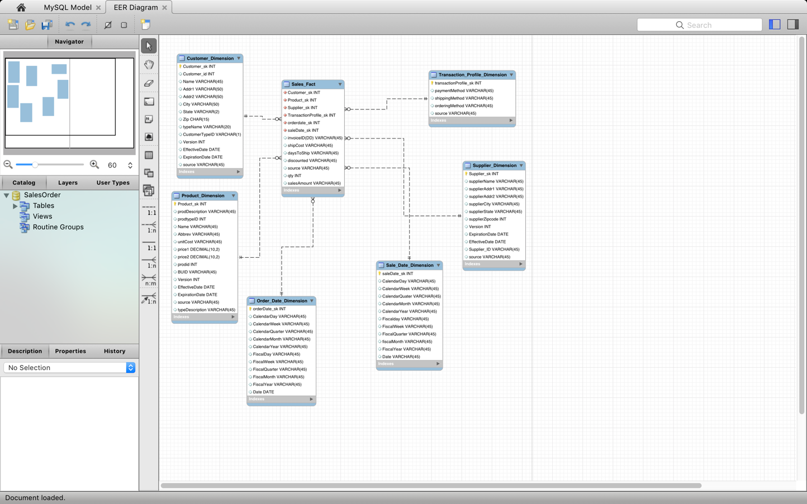

**Dimensional Model:**

This schema consists of dimensions, i.e. Customer, Product, Supplier, Transaction profile, Sales Date and Order date dimensions. They are used to represent record in the database SalesOrder. Sales_Fact table consists of the facts for the database. In this fact table, we calculate the no of days to ship, quantity etc. Invoice ID is the degenerating dimension.

**Crows Foot Diagram:**

Screenshots of all the dimensions and fact tables including the **attributes**, **entities** and **primary keys** and **relationships** of each dimension along with **de-normalize data** in the **Crows-Foot** format.

1. **Customer Dimension**

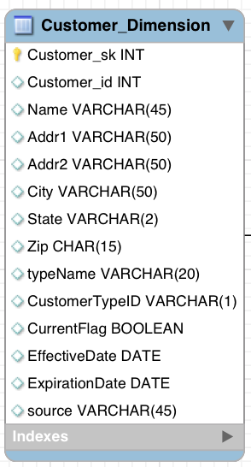

This is the customer dimension table

1. **Product Dimension**

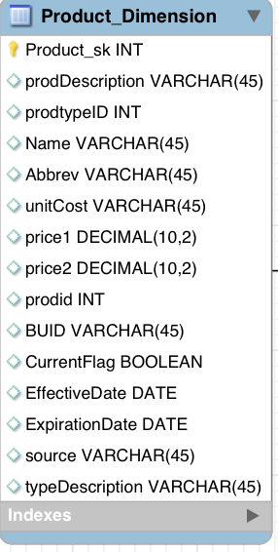

This is the product dimension table

1. **Supplier Dimension**

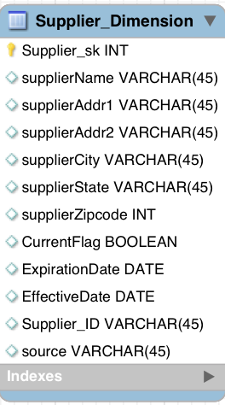

This is the supplier dimension table

1. **Order date dimension**

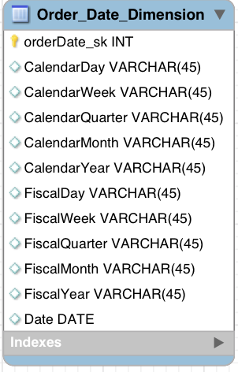

This is the order data dimension

1. **Sale date dimension**

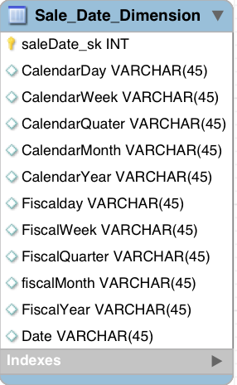

This is the sale date dimension

1. **Transaction Profile Dimension**

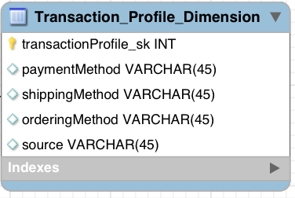

This is the transaction profile (which is the junk dimension)

1. **Sales Fact**

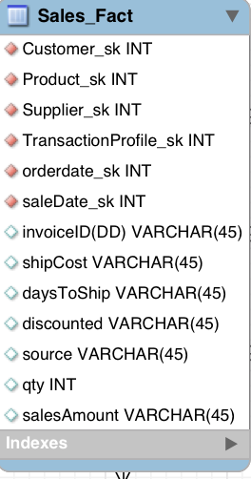

This is the sale fact table

# III. Data Staging: ETL – Data Extract File Definitions

|  |  |  |  |
| --- | --- | --- | --- |
| **Dimension** | **Source files** | | **Source Type** |
| Customer Dimension | TPC-E | Customer | File (.csv) |
| CustomerType_new | File (.csv) |
| TPC-W | TPCWcustomer | File (.csv) |
| TPCWcustomer_type | File (.csv) |
| PEC | PECcustomer | File (.csv) |
| PECcustomer_type | File (.csv) |
| Transaction  Profile Dimension | TPC-E | None | None |
| TPC-W | None | None |
| PEC | PEC_invoice | File (.csv) |
| Product Dimension | TPC-E | Product | File (.csv) |
| ProdType | File (.csv) |
| BusinessUnit_New | File (.csv) |
| TPC-W | TPCWproduct | File (.csv) |
| TPCWproduct_type | File (.csv) |
| TPCWbusiness_unit | File (.csv) |
| PEC | PECproduct | File (.csv) |
| PECproduct_type | File (.csv) |
| PECbusiness_unit | File (.csv) |
| Supplier Dimension | TPC-E | Supplier | File (.csv) |
| TPC-W | TPCWProduct | File (.csv) |
| PEC | PECproduct | File (.csv) |
| Sales Fact | TPC-E | TPCEInvoice.hdr | File (.csv) |
| TPCEInvoice.dtl | File (.csv) |
| TPC-W | TPCWproduct  TPCWinvoice | File (.csv) |
| PEC | PECproduct  PECinvoice | File (.csv) |

|  |  |  |  |
| --- | --- | --- | --- |
| Order Date Dimension | TPC-E | None |  |
| TPC-W | None |  |
| PEC | PECInvoice | File (.csv) |

|  |  |  |  |
| --- | --- | --- | --- |
| Sale Date Dimension | TPC-E | TPCEInvoice | File (.csv) |
| TPC-W | TPCWInvoice | File (.csv) |
| PEC | PECInvoice | File (.csv) |

# IV. Data Staging: ETL – Source-to-Target Mappings

Follow the same format as indicated in “The Data Warehouse ETL Toolkit” by Kimball & Caserta, Fig. 3.1 on page 60. This is available on Books 24x7. The table should be in alphabetical order table name and column name.

|  |  |
| --- | --- |
| Target | Source |

|  |  |  |  |  |  |  |  |  |  |
| --- | --- | --- | --- | --- | --- | --- | --- | --- | --- |
| **Table Name** | **Table Type** | **Column Name** | **Data Type** | **SCD Type** | **Database** | **Table Name** | **Column Name** | **Data Type** | **Transformation** |
| Customer | Dimension | Customer_sk | Int | 0 |  |  |  |  | Auto-Increment Value Surrogate Key- Customer_SK |
| Customer | Dimension | Customer_id | Int | 0 | TPCE  TPCW  PEC | customer.csv  TPCWcustomer.csv  PECcustomer.csv | custID  custID  custID | Numeric  Numeric  Numeric | -Changed attribute name to Customer_ ID as per the standardization |
| Customer | Dimension | Name | Varchar | 1 | TPCE  TPCW  PEC | customer.csv  TPCWcustomer.csv  PECcustomer.csv | NAME  name  NAME | Text  Text  Text | -Changed attribute to Name as per the standardization |
| Customer | Dimension | Addr1 | Varchar | 2 | TPCE  TPCW  PEC | customer.csv  TPCWcustomer.csv  PECcustomer.csv | ADDR1  Address  Address | Text  Text  Text | -Input from file for TPCE.  -Split the Address field into addr1 and addr2 for TPCW and PEC using pentaho. |
| Customer | Dimension | Addr2 | Varchar | 2 | TPCE  TPCW  PEC | customer.csv  TPCWcustomer.csv  PECcustomer.csv | ADDR2  Address  Address | Text  Text  Text | -Input from file for TPCE.  -Split the Address field into addr1 and addr2 for TPCW and PEC using pentaho. |
| Customer | Dimension | City | Varchar | 2 | TPCE  TPCW  PEC | customer.csv  TPCWcustomer.csv  PECcustomer.csv | CITY  city  city | Text  Text  Text | -Changed attribute name to city as per the standardization for TPCE.  -Input from File for TPCW and PEC. |
| Customer | Dimension | State | Varchar | 2 | TPCE  TPCW  PEC | customer.csv  TPCWcustomer.csv  PECcustomer.csv | STATE  state  state | Text  Text  Text | -Changed attribute name to State as per the standardization for TPCE.  -Input from File for TPCW and PEC. |
| Customer | Dimension | Zip | Varchar | 2 | TPCE  TPCW  PEC | customer.csv  TPCWcustomer.csv  PECcustomer.csv | ZIP  zip  zip | Numeric  Numeric  Numeric | -Changed attribute name to Zip as per the standardization for TPCE.  -Input from File for TPCW and PEC. |
| Customer | Dimension | typeName | Varchar | 2 | TPCE  TPCW  PEC | customer.csv  TPCWcustomer.csv  PECcustomer.csv | TYPENAME  TYPENAME  TYPENAME | Text  Text  Text | Join was performed on customer on custTypeID and renamed it to typeName as per the standardization. |
| Customer | Dimension | CustomerTypeID | Int | 2 | TPCE  TPCW  PEC | customer.csv  TPCWcustomer.csv  PECcustomer.csv | CUSTTYPEID  CUSTTYPEID  CUSTTYPEID | Numeric  Numeric  Numeric | Join was performed on customer on custTypeID and renamed it to typeName as per the standardization. |
| Customer | Dimension | Source | varchar | 2 | TPCE  TPCW  PEC | customer.csv  TPCWcustomer.csv  PECcustomer.csv |  |  | Added value called TPCE, TPCW and PEC using Pentaho. |
| Order_date | Dimension | OrderDate_sk |  | 0 |  |  |  |  | Auto-Increment value ProductID Surrogate Key – Order_date_SK |
| Order_date | Dimension | Date | Date | 0 | PEC  TPC-W  TPC-E | PEC invoice | orderDate | DATE | Extracted order date from PEC invoice and using penatho calculated month,date and year from order Date renamed Date. For TPCW and TPCE we used null records |
| Order_date | Dimension | CalendarDay | Int | 0 | PEC  TPC-W  TPC-E | PEC invoice | orderDate | DATE | Extracted order date from PEC invoice and using pentaho calculated month, date and year from order Date renamed Date. For TPCW and TPCE we used null records |
| Order_date | Dimension | CalendarWeek | Int | 0 | PEC  TPC-W  TPC-E | PEC invoice | orderDate | DATE | Extracted order date from PEC invoice and using penatho calculated month, date and year from order Date renamed Date. For TPCW and TPCE we used null records |
| Order_date | Dimension | CalendarQuarter | Int | 0 | PEC  TPC-W  TPC-E | PEC invoice | orderDate | DATE | Extracted order date from PEC invoice and using penatho calculated month,date and year from order Date renamed Date. For TPCW and TPCE we used null records |
| Order_date | Dimension | CalendarMonth | Int | 0 | PEC  TPC-W  TPC-E | PEC invoice | orderDate | DATE | Extracted order date from PEC invoice and using penatho calculated month,date and year from order Date renamed Date. For TPCW and TPCE we used null records |
| Order_date | Dimension | CalendarYear | Int | 0 | PEC  TPC-W  TPC-E | PEC invoice | orderDate | DATE | Extracted order date from PEC invoice and using penatho calculated month,date and year from order Date renamed Date. For TPCW and TPCE we used null records |
| Order_date | Dimension | FiscalDay | Int | 0 | PEC  TPC-W  TPC-E | PEC invoice | orderDate | DATE | Calcaluted Fiscal order date from PEC invoice and using penatho calculated month,date and year from order Date renamed Date. For TPCW and TPCE we used null records |
| Order_date | Dimension | FiscalWeek | Int | 0 | PEC  TPC-W  TPC-E | PEC invoice | orderDate | DATE | Calcaluted Fiscal order date from PEC invoice and using penatho calculated month,date and year from order Date renamed Date. For TPCW and TPCE we used null records |
| Order_date | Dimension | FiscalQuarter | Int | 0 | PEC  TPC-W  TPC-E | PEC invoice | orderDate | DATE | Calcaluted Fiscal order date from PEC invoice and using penatho calculated month,date and year from order Date renamed Date. For TPCW and TPCE we used null records |
| Order_date | Dimension | FiscalMonth | Int | 0 | PEC  TPC-W  TPC-E | PEC invoice | orderDate | DATE | Calcaluted Fiscal order date from PEC invoice and using penatho calculated month,date and year from order Date renamed Date. For TPCW and TPCE we used null records |
| Order_date | Dimension | FiscalYear | Int | 0 | PEC  TPC-W  TPC-E | PEC invoice | orderDate | DATE | Calcaluted Fiscal order date from PEC invoice and using penatho calculated month,date and year from order Date renamed Date. For TPCW and TPCE we used null records |
| Product | Dimension | Product_SK | Int | 0 |  |  |  |  | Auto-Increment value ProductID Surrogate Key – ProductID_SK |
| Product | Dimension | prodid | Int | 0 | TPCE  TPCW  PEC | Product.csv  TPCWproduct.csv  PECproduct.csv | description  No header  prodiddescription | Numeric  Numeric  Numeric | -From Input File  -Changed attribute name to prodid as per the standardization for PEC |
| Product | Dimension | ProdTypeID | Int | 0 | TPC-E  TPC-W  PEC | Product  TPCWproduct  PECproduct | prodTypeID  No header  prodid | Numeric  Numeric  Numeric | Renamed the column to prodTypeID |
| Product | Dimension | prodDescription | Varchar | 2 | TPCE  TPCW  PEC | Product.csv  TPCWproduct.csv  PECproduct.csv | Product Name  No header  prodDescription | Text  Text  Text | -From Input File  for TPCE and PEC.  -Changed attribute name to prodDescription as per the standardization for TPCW. |
| Product | Dimension | typeDescription | Varchar | 2 | TPC-E  TPC-W  PEC | TPCEproduct_type.csv  TPCproduct_type.csv  PECproduct_type.csv | typeDescription  No Header  typeDescription | Text  Text  Text | Changed attribute name to typeDescription as per the standardization for TPCW. |
| Product | Dimension | Price1 | Boolean | 1 | TPC-E  TPC-W  PEC | TPC-E  TPCWproduct  PECproduct | Price1  No Header  Price1 | Numeric  Numeric  Numeric | Verified the data type. |
| Product | Dimension | Price2 | Boolean | 1 | TPC-E  TPC-W  PEC | TPC-E  TPCWproduct  PECproduct | Price2  No Header  Price2 | Numeric  Numeric  Numeric | Verified the data type. |
| Product | Dimension | BUID | Varchar | 0 | PEC  TPC-W  TPC-E | PECbusiness_unit  TPCWbusiness_unit  TPCE_business_unit_new | BUID  No Header  BUSINESS_UNIT | Text  Text  Text | -Verified the name for TPCE and PEC  -Changed attribute name to BUID for TPCW. |
| Product | Dimension | Name | Varchar | 2 | PEC  TPC-W  TPC-E | PECbusiness_unit  TPCWbusiness_unit  TPCE_business_unit_new | Name  No Header  name | Text  Text  Text | -Changed attribute name to Name for TPCW, PEC and TPCW. |
| Product | Dimension | Abbrev | Varchar | 2 | PEC  TPC-W  TPC-E | PECbusiness_unit  TPCWbusiness_unit  TPCE_business_unit_new | Abbrev  No header  abbrev | Text  Text  Text | -Changed attribute name to Abbrev for TPCW, PEC and TPCW. |
| Product | Dimension | unitCost | Boolean | 2 | PEC  TPC-W  TPC-E | PECproduct.csv  TPCWproduct.csv  Product.csv | unitCost  No Header  uniCost | Float  Float  decimal | Calculated unit cost using pentaho |
| Product | Dimension | Source | varchar | 0 | PEC  TPC-W  TPC-E | PECproduct.csv  TPCWproduct.csv  Product.csv |  |  | Added value called TPCE, TPCW and PEC using Pentaho. |
| Sales_date | Dimension | SaleDate_sk |  | 0 |  |  |  |  | Auto-Increment value ProductID Surrogate Key – SalesDate_SK |
| Sales_date | Dimension | Date | Date | 0 | PEC  TPC-W  TPC-E | PEC invoice  TPCWinvoice  TPCEinvoice | salesDate  salesDate  salesDate | DATE | Extracted sales date from invoices and using penatho calculated month,date and year from sale Date renamed Date. |
| Sales_date | Dimension | CalendarDay | Int | 0 | PEC  TPC-W  TPC-E | PEC invoice  TPCWinvoice  TPCEinvoice | salesDate  salesDate  salesDate | DATE | Extracted sales date from invoices and using penatho calculated month,date and year from sales date |
| Sales_date | Dimension | CalendarWeek | Int | 0 | PEC  TPC-W  TPC-E | PEC invoice  TPCWinvoice  TPCEinvoice | salesDate  salesDate  salesDate | DATE | Extracted sales date from invoices and using penatho calculated month,date and year from sales date |
| Sales_date | Dimension | CalendarQuarter | Int | 0 | PEC  TPC-W  TPC-E | PEC invoice  TPCWinvoice  TPCEinvoice | salesDate  salesDate  salesDate | DATE | Extracted sales date from invoices and using penatho calculated month,date and year from sales date |
| Sales_date | Dimension | CalendarMonth | Int | 0 | PEC  TPC-W  TPC-E | PEC invoice  TPCWinvoice  TPCEinvoice | salesDate  salesDate  salesDate | DATE | Extracted sales date from invoices and using penatho calculated month,date and year from sales date |
| Sales_date | Dimension | CalendarYear | Int | 0 | PEC  TPC-W  TPC-E | PEC invoice  TPCWinvoice  TPCEinvoice | salesDate  salesDate  salesDate | DATE | Extracted sales date from invoices and using penatho calculated month,date and year from sales date |
| Sales_date | Dimension | FiscalDay | Int | 0 | PEC  TPC-W  TPC-E | PEC invoice  TPCWinvoice  TPCEinvoice | salesDate  salesDate  salesDate | DATE | Calcaluted Fiscal sales date from PEC invoice and using penatho calculated month,date and year from sales date |
| Sales_date | Dimension | FiscalWeek | Int | 0 | PEC  TPC-W  TPC-E | PEC invoice  TPCWinvoice  TPCEinvoice | salesDate  salesDate  salesDate | DATE | Calcaluted Fiscal sales date from PEC invoice and using penatho calculated month,date and year from sales date |
| Sales_date | Dimension | FiscalQuarter | Int | 0 | PEC  TPC-W  TPC-E | PEC invoice  TPCWinvoice  TPCEinvoice | salesDate  salesDate  salesDate | DATE | Calcaluted Fiscal sales date from PEC invoice and using penatho calculated month,date and year from sales date |
| Sales_date | Dimension | FiscalMonth | Int | 0 | PEC  TPC-W  TPC-E | PEC invoice  TPCWinvoice  TPCEinvoice | salesDate  salesDate  salesDate | DATE | Calcaluted Fiscal sales date from PEC invoice and using penatho calculated month,date and year from sales date |
| Sales_date | Dimension | FiscalYear | Int | 0 | PEC  TPC-W  TPC-E | PEC invoice  TPCWinvoice  TPCEinvoice | salesDate  salesDate  salesDate | DATE | Calcaluted Fiscal sales date from PEC invoice and using penatho calculated month,date and year from sales date |
| Sales_fact | Fact | Customer_sk | Int |  | Customer dimension table |  |  |  | Extracted surrogate key from Customer dimension table |
| Sales_fact | Fact | Supplier_sk | Int |  | Supplier |  |  |  | Extracted surrogate key from Supplier dimension table |
| Sales_fact | Fact | Product_sk | Int |  | Product |  |  |  | Extracted surrogate key from Product dimension table |
| Sales_fact | Fact | OrderDate_sk | Int |  | Order_date |  |  |  | Extracted surrogate key from Order date dimension table |
| Sales_fact | Fact | SaleDate_sk | Int |  | Sales_date |  |  |  | Extracted surrogate key from Sales date dimension table |
| Sales_fact | Fact | TransactionProfile_sk | Int |  | Transaction_profile |  |  |  | Extracted surrogate key from Transaction_profile dimension table |
| Sales_fact | Fact | Qty | Int |  | PEC  TPC-W  TPC-E | PEC invoice  TPCWinvoice  TPCEinvoice_details | qty  qty  qty | Numeric  numeric | Extracted from the imout file |
| Sales_fact | Fact | InvoiceID | Int | 1 | PEC  TPC-W  TPC-E | PEC invoice  TPCWinvoice  TPCEinvoice | Invoice  Invoice  invoiceID | Numeric  Numeric  Numeric | Renamed the column to InvoiceID |
| Sales_fact | Fact | shipCost | Boolean |  |  |  |  |  | Calculated using the calculator in pentaho |
| Sales_fact | Fact | InvoiceID | Int |  | PEC  TPC-W  TPC-E | PEC invoice  TPCWinvoice  TPCEinvoice | Invoice  Invoice  invoiceID | Numeric  Numeric  Numeric |  |
| Sales_fact | Fact | salesAmount | Int |  | PEC  TPC-W  TPC-E | PEC invoice  TPCWinvoice  TPCEinvoice | amt  amt  amt |  | Renamed the column to salesAmount |
| Sales_fact | Fact | discounted | Int |  | PEC  TPC-W  TPC-E | PEC invoice  TPCWinvoice  TPCEinvoice_details | discounted  discounted  discounted | Numeric  Numeric  Numeric | Checked the column name. |
| Supplier | Dimension | Supplier_sk | Int | 0 | TPCE  TPCW  PEC | Product.csv  TPCWproduct.csv  Supplier.csv |  |  | Auto-Increment Value for Surrogate Key Supplier_sk |
| Supplier | Dimension | Supplier_id | Int | 0 | TPCE  TPCW  PEC | Product.csv  TPCWproduct.csv  Supplier.csv | supplierID  No Header  supplierID | Numeric  Numeric  Numeric | Supplier_id missing manualy added for PEC  Inout file for TPCE TPCW |
| Supplier | Dimension | SupplierName | Varchar | 2 | TPCE  TPCW  PEC | Product.csv  TPCWproduct.csv  Supplier.csv | supplierName  No header  NAME | Text  Text  Text | -Renamed the column to SupplierName. |
| Supplier | Dimension | SupplierAddr1 | Varchar | 2 | TPCE  TPCW  PEC | Product.csv  TPCWproduct.csv  Supplier.csv | ADDR1  No header | Text  Text | Assigned default value to addr for PEC  -Split the Address field into addr1 and addr2 for TPCW and PEC using pentaho. |
| Supplier | Dimension | SupplierAddr2 | Varchar | 2 | TPCE  TPCW  PEC | Product.csv  TPCWproduct.csv  Supplier.csv | ADDR2  No header | Text  Text | Assigned default value to addr 2 for PEC  -Split the Address field into addr1 and addr2 for TPCW and PEC using pentaho. |
| Supplier | Dimension | SupplierCity | Varchar | 2 | TPCE  TPCW  PEC | Product.csv  TPCWproduct.csv  Supplier.csv | City  No header  City | Text  Text  Text | -Renamed the column to SupplierCity |
| Supplier | Dimension | SuplierState | Varchar | 2 | TPCE  TPCW  PEC | Product.csv  TPCWproduct.csv  Supplier.csv | State  No header  State | Text  Text  Text | -Renamed the column to SupplierState |
| Supplier | Dimension | SuplierZip | Int | 2 | TPCE  TPCW  PEC | Product.csv  TPCWproduct.csv  Supplier.csv | Zip  No header  Zip | Numeric  Numeric  Numeric | -Renamed the column to SupplierZip. |
| Supplier | Dimension | Source | varchar |  | TPCE  TPCW  PEC | Product.csv  TPCWproduct.csv  Supplier.csv |  |  | Added value called TPCE, TPCW and PEC using Pentaho. |
| Transaction profile | Dimension | Transaction_profile_sk | Int | 0 |  |  |  |  | Auto-Increment Value for Surrogate Key Transaction_profile_sk |
| Transaction profile | Dimension | shippingMethod | varchar | 1 | PEC | PEC invoice | shippingMethod | Text | Retained value for PEC and null values for the other two. |
| Transaction profile | Dimension | paymentMethod | varchar | 0 | PEC | PEC invoice | paymentMethod | Text | Retained value for PEC and null values for the other two. |
| Transaction profile | Dimension | orderMethod | varchar | 0 | PEC | PEC invoice | orderMethod | Text | Retained value for PEC and null values for the other two. |

# 

# V. SQL Code – Tables & Constraints

- -- MySQL Workbench Forward Engineering

-- Host: localhost Database: salesorder

-- ------------------------------------------------------

-- Server version 5.7.16

/*!40101 SET @OLD_CHARACTER_SET_CLIENT=@@CHARACTER_SET_CLIENT */;

/*!40101 SET @OLD_CHARACTER_SET_RESULTS=@@CHARACTER_SET_RESULTS */;

/*!40101 SET @OLD_COLLATION_CONNECTION=@@COLLATION_CONNECTION */;

/*!40101 SET NAMES utf8 */;

/*!40103 SET @OLD_TIME_ZONE=@@TIME_ZONE */;

/*!40103 SET TIME_ZONE='+00:00' */;

/*!40014 SET @OLD_UNIQUE_CHECKS=@@UNIQUE_CHECKS, UNIQUE_CHECKS=0 */;

/*!40014 SET @OLD_FOREIGN_KEY_CHECKS=@@FOREIGN_KEY_CHECKS, FOREIGN_KEY_CHECKS=0 */;

/*!40101 SET @OLD_SQL_MODE=@@SQL_MODE, SQL_MODE='NO_AUTO_VALUE_ON_ZERO' */;

/*!40111 SET @OLD_SQL_NOTES=@@SQL_NOTES, SQL_NOTES=0 */;

DROP DATABASE IF EXISTS salesorder;

CREATE DATABASE salesorder;

use salesorder;

--------------------------------------------------------------------------------------------

-- Table structure for table `Customer_Dimension`

--

DROP TABLE IF EXISTS `Customer_Dimension`;

/*!40101 SET @saved_cs_client = @@character_set_client */;

/*!40101 SET character_set_client = utf8 */;

CREATE TABLE `Customer_Dimension` (

`Customer_sk` int(11) NOT NULL,

`Customer_id` int(20) DEFAULT NULL,

`Version` int(11) DEFAULT NULL,

`Name` varchar(45) DEFAULT NULL,

`Addr1` varchar(45) DEFAULT NULL,

`Addr2` varchar(45) DEFAULT NULL,

`City` varchar(45) DEFAULT NULL,

`State` varchar(45) DEFAULT NULL,

`Zip` char(45) DEFAULT NULL,

`typeName` varchar(45) DEFAULT NULL,

`CustomerTypeID` varchar(45) DEFAULT NULL,

`EffectiveDate` date DEFAULT NULL,

`ExpirationDate` date DEFAULT NULL,

`source` varchar(45) DEFAULT NULL,

PRIMARY KEY (`Customer_sk`),

KEY `idx_Customer_Dimension_lookup` (`Customer_id`)

) ENGINE=InnoDB DEFAULT CHARSET=utf8;

/*!40101 SET character_set_client = @saved_cs_client */;

--

-- Table structure for table `Order_Date_Dimension`

--

DROP TABLE IF EXISTS `Order_Date_Dimension`;

/*!40101 SET @saved_cs_client = @@character_set_client */;

/*!40101 SET character_set_client = utf8 */;

CREATE TABLE `Order_Date_Dimension` (

`orderDate_sk` int(11) NOT NULL,

`CalendarDay` varchar(45) DEFAULT NULL,

`CalendarWeek` varchar(45) DEFAULT NULL,

`CalendarQuarter` varchar(45) DEFAULT NULL,

`CalendarMonth` varchar(45) DEFAULT NULL,

`CalendarYear` varchar(45) DEFAULT NULL,

`FiscalDay` varchar(45) DEFAULT NULL,

`FiscalWeek` varchar(45) DEFAULT NULL,

`FiscalQuarter` varchar(45) DEFAULT NULL,

`FiscalMonth` varchar(45) DEFAULT NULL,

`FiscalYear` varchar(45) DEFAULT NULL,

`Date` date DEFAULT NULL,

PRIMARY KEY (`orderDate_sk`)

) ENGINE=InnoDB DEFAULT CHARSET=utf8;

/*!40101 SET character_set_client = @saved_cs_client */;

--

-- Table structure for table `Product_Dimension`

--

DROP TABLE IF EXISTS `Product_Dimension`;

/*!40101 SET @saved_cs_client = @@character_set_client */;

/*!40101 SET character_set_client = utf8 */;

CREATE TABLE `Product_Dimension` (

`Product_sk` int(11) NOT NULL,

`prodDescription` varchar(45) DEFAULT NULL,

`prodtypeID` int(11) DEFAULT NULL,

`Name` varchar(45) DEFAULT NULL,

`Abbrev` varchar(45) DEFAULT NULL,

`unitCost` varchar(45) DEFAULT NULL,

`price1` decimal(10,2) DEFAULT NULL,

`price2` decimal(10,2) DEFAULT NULL,

`prodid` int(11) DEFAULT NULL,

`BUID` varchar(11) DEFAULT NULL,

`Version` int(11) DEFAULT NULL,

`EffectiveDate` date DEFAULT NULL,

`ExpirationDate` date DEFAULT NULL,

`source` varchar(45) DEFAULT NULL,

`typeDescription` varchar(45) DEFAULT NULL,

PRIMARY KEY (`Product_sk`)

) ENGINE=InnoDB DEFAULT CHARSET=utf8;

/*!40101 SET character_set_client = @saved_cs_client */;

--

-- Table structure for table `Sale_Date_Dimension`

--

DROP TABLE IF EXISTS `Sale_Date_Dimension`;

/*!40101 SET @saved_cs_client = @@character_set_client */;

/*!40101 SET character_set_client = utf8 */;

CREATE TABLE `Sale_Date_Dimension` (

`saleDate_sk` int(11) NOT NULL,

`CalendarDay` varchar(45) DEFAULT NULL,

`CalendarWeek` varchar(45) DEFAULT NULL,

`CalendarQuarter` varchar(45) DEFAULT NULL,

`CalendarMonth` varchar(45) DEFAULT NULL,

`CalendarYear` varchar(45) DEFAULT NULL,

`Fiscalday` varchar(45) DEFAULT NULL,

`FiscalWeek` varchar(45) DEFAULT NULL,

`FiscalQuarter` varchar(45) DEFAULT NULL,

`fiscalMonth` varchar(45) DEFAULT NULL,

`FiscalYear` varchar(45) DEFAULT NULL,

`Date` date DEFAULT NULL,

PRIMARY KEY (`saleDate_sk`)

) ENGINE=InnoDB DEFAULT CHARSET=utf8;

/*!40101 SET character_set_client = @saved_cs_client */;

--

-- Table structure for table `Sales_Fact`

--

DROP TABLE IF EXISTS `Sales_Fact`;

/*!40101 SET @saved_cs_client = @@character_set_client */;

/*!40101 SET character_set_client = utf8 */;

CREATE TABLE `Sales_Fact` (

`Customer_sk` int(11) NOT NULL,

`Product_sk` int(11) NOT NULL,

`Supplier_sk` int(11) NOT NULL,

`TransactionProfile_sk` int(11) NOT NULL,

`orderDate_sk` int(11) NOT NULL,

`saleDate_sk` int(11) NOT NULL,

`invoiceID(DD)` varchar(45) DEFAULT NULL,

`shipCost` varchar(45) DEFAULT NULL,

`daysToShip` varchar(45) DEFAULT NULL,

`discounted` varchar(45) DEFAULT NULL,

`source` varchar(45) DEFAULT NULL,

`qty` int(20) DEFAULT NULL,

`salesAmount` varchar(45) DEFAULT NULL

) ENGINE=InnoDB DEFAULT CHARSET=utf8;

/*!40101 SET character_set_client = @saved_cs_client */;

DROP TABLE IF EXISTS `Supplier_Dimension`;

/*!40101 SET @saved_cs_client = @@character_set_client */;

/*!40101 SET character_set_client = utf8 */;

CREATE TABLE `Supplier_Dimension` (

`Supplier_sk` int(11) NOT NULL,

`supplierName` varchar(80) DEFAULT NULL,

`supplierAddr1` varchar(45) DEFAULT NULL,

`supplierAddr2` varchar(45) DEFAULT NULL,

`supplierCity` varchar(45) DEFAULT NULL,

`supplierState` varchar(45) DEFAULT NULL,

`supplierZipcode` int(11) DEFAULT NULL,

`Version` int(11) DEFAULT NULL,

`ExpirationDate` date DEFAULT NULL,

`EffectiveDate` date DEFAULT NULL,

`supplierID` int(11) DEFAULT NULL,

`source` varchar(45) DEFAULT NULL,

PRIMARY KEY (`Supplier_sk`)

) ENGINE=InnoDB DEFAULT CHARSET=utf8;

/*!40101 SET character_set_client = @saved_cs_client */;

-- Table structure for table `Transaction_Profile_Dimension`

--

DROP TABLE IF EXISTS `Transaction_Profile_Dimension`;

/*!40101 SET @saved_cs_client = @@character_set_client */;

/*!40101 SET character_set_client = utf8 */;

CREATE TABLE `Transaction_Profile_Dimension` (

`transactionProfile_sk` int(11) NOT NULL,

`payementMethod` varchar(45) DEFAULT NULL,

`shippingMethod` varchar(45) DEFAULT NULL,

`orderingMethod` varchar(45) DEFAULT NULL,

`source` varchar(45) DEFAULT NULL,

PRIMARY KEY (`transactionProfile_sk`)

) ENGINE=InnoDB DEFAULT CHARSET=utf8;

/*!40101 SET character_set_client = @saved_cs_client */;

# VI. Data Staging Activities - ETL

## **Data Cleansing**

|  |  |  |  |
| --- | --- | --- | --- |
| **DM Table** | **Attribute** | **Problem** | **Resolution Strategy (attach code)** |
| PECcustomer | CustID, Address, Custtype | The Values were enclosed in double quotes & comma | Replaced double quotes & Comma with space in the fields by using replace in string in pentaho. |
| PECcustomer | Address | There was no delimiter to split | Added Comma delimiter in address field to split into addr1 & addr2 in csv file of customer. |
| PECcustomer | Address | The address field was not consistent with the fields in TPCE | Split the address into addr1 and addr2 using Spilt in pentaho. |
| PECcustomer | Name | Some records had Co., Corp so standardized them | Standardized the name,  Inc. to Inc  Co. to Company  Corp to Corporation by using replace in string in pentaho. |
| PECcustomer | Add1 & Addr2 | Some records had St, Ave and Rd etc so standardized them | Standardized the addr1 & addr2,  Rd. to Road  St. to Street  Dr. to Drive  Av. To Avenue  Ave. to Avenue  Auctor, to Auctor  At, to At  Ornare. to Ornare  Eleifend. to Eleifend  Leo. To Leo  Dictum.to Dictum  Nisl. To Nisl  Risus. to Risus  Eu, to Eu  Aliquet. to Aliquet  Tincidunt. to Tincidunt  P.O. Box 825, to P.O. Box 825  by using replace in string in pentaho. |
| PECcustomer | Typename | Some records were upper case  so, standardized them | Standardized typename from upper to lower case using replace in string in pentaho. |
| PECcustomer_type | Typename | Some records had Gov so standardized them | Standardized State/Local Gov to State/Local Govt using replace in string in pentaho. |
| TPCWcustomer | All Fields | The Values were enclosed in double quotes & comma | Replaced double quotes & Comma with space in the fields using replace in string in pentaho. |
| TPCWCcustomer | State | Records in PEC & TPE was abbreviated while TPCW had complete name | Standardized all the state names with their ABBREV using replace in string in pentaho. |
| TPCWcustomer | Typename | Some records had Gov ,Comm. Edu so standardized them | Standardized Govt to US Govt  State to State/Local Govt  Comm to Commercial  Edu to Education  using replace in string in pentaho. |
| TPCWcustomer | Address | There was no delimiter to split | Added Comma delimiter in address field to split into addr1 & addr2 in the Csv file. |
| TPCWcustomer | Address | The address field was not consistent with the fields in TPCE | Split the address into addr1 and addr2 using split in pentaho. |
| TPCWcustomer | Name | Some records had Co., Corp etc. so standardized them | Standardized the name, Inc. to Inc, Co. to Company, Corp to Corporation.  Firstfed America BanCompany to Firstfed America Ban Company  using replace in string in pentaho. |
| TPCWcustomer | Add1 & Addr2 | Some records had St, Ave and Rd etc. so standardized them | Standardized the addr1 & addr2,  Rd. to Road  St. to Street  Dr. to Drive  Av. to Avenue  Ave. to Avenue  Auctor, to Auctor  At, to At  Ornare. to Ornare  Eleifend. to Eleifend  Leo. to Leo  Dictum.to Dictum  Nisl. to Nisl  Risus. to Risus  Eu, to Eu  Aliquet. to Aliquet  Tincidunt. to Tincidunt  P.O. Box 825, to P.O. Box 825  Lacus. to Lacus  Urna. to Urna  Squash.. to Squash  Rhoncus. to Rhoncus  using replace in string in pentaho. |
| TPCWcustomer_type | Typename | Some records had Gov so standardized them | Standardized State/Local Gov to State/Local Govt using replace in string in pentaho. |
| TPEcustomer | All Fields | The Values were enclosed in double quotes | Replaced double quotes with space in the fields using replace in string in pentaho. |
| TPEcustomer | Name | Some records had Co., Corp etc so standardized them | Standardized the name,  Inc. to Inc  Co. to Company  Corp to Corporation by using replace in string in pentaho. |
| TPEcustomer | Header Fields | The Values were enclosed in double quotes | Replaced double quotes with space in the fields using replace in string in pentaho. |
| PECbusinessunit.csv | ABBREV | Null value(BUID=D) | Added missing value |
| TPCWbusiness_unit.csv | ABBREV | Null value(BUID=D) | Added missing value |
| TPCEbusinessunit.csv | ABBREV | Null value(BUID=D) | Added missing value |
| PECinvoice | All Fields except orderDate | Remove | Select orderDate by using replace in string in pentaho to separate orderDate from the csv file. |
| PECinvoice | All Fields except saleDate | Remove | Select orderDate by using replace in string in pentaho to separate orderDate from the csv file. |
| PECinvoice.csv | orderDate & saleDate | Standardization | Standardization the date by removing ‘-‘ and adding ‘/’. |
| PECinvoice.csv | All fields | Standardization | Standardization records according to proper sequence in the csv file. |
| TPCWinvoice.csv | saleDate | Remove | One invoiceid had extra column with Header values so removed that by keeping null. |
| TPCWinvoice.csv | saleDate | Standardization | Standardization the date by removing ‘-‘ & adding ‘/’. |
| TPCWinvoice.csv | saleDate | Standardization | Standardization the date to mm/dd/yyyy |
| TPCWinvoice.csv | Custid | Standardization | Negative values were changed to absolute values. |
| PECinvoice | CalendarYear  CalendarQuarter  CalendarMonth  CalendarWeek  CalendarDay | Using calculator  Year of date A  Quarter of date A  Month of date A  Week of date A  Day of month of date A | We take orderDate and using calculator in pentaho we spilt into  CalendarYear  CalendarQuarter  CalendarMonth  CalendarWeek  CalendarDay |
| PECinvoice | FiscalYear  FiscalQuarter  FiscalMonth  FiscalWeek  FiscalDay |  | Calculated FiscalYear  FiscalQuarter  FiscalMonth  FiscalWeek  FiscalDay using modified javascript in pentaho.  (For both sale and order dates) |
| SupplierTPCE | NAME  ADDR1  ADDR2  CITY  STATE  ZIP  SUPPLIERID | Standardization | Standardized these attributes using select values to  supplierName  supplierAddr1  supplierAddr2  supplierState  supplierCity  suppplierZipcode  supplierID |
| ProductTPCW | Field_005  Field_006  Field_007  Field_008  Field_009 | Standarization | Extracted all the values and renamed them to  supplierName  supplierAddr1  supplierAddr2  supplierCityState  supplierZipcode |
| ProductTPCW | supplierCityState | Combined | Splitted city and state using split fields to  supplierCity  supplierState |
| ProductTPCW | supplierAddr2  supplierCity  supplierState | Wrong Name | Name of city, state and address 2 were not complete or mis-spelled. Changed name using replace in string.  Talahassee to Tallahassee  Ave”” to Avenue””  Careless to Carelessly  FI to Fl  3737 to 3727  St”” to Street””  6027 to 6037 |
| ProductTPCW | supplierName  supplierAddr1  supplierAddr2  supplierState  supplierCity  suppplierZipcode  supplierID | Duplicate Rows | Duplicate rows were removed using Unique rows (Hash Set) |
| ProductTPCW | supplierAddr1 | Extra attribute Attn : | Attn: was removed] before all address 1 in supplier were using replace in string. |
| ProductPEC | prodid  prodDescription  price1  price2  unitCost  productTypeID | extra attributes | These extra fields value were removed using select value and extracted supplierName. |
| ProductPEC | supplierName | Null Values | All null values are removed using unique row and we got a TPC West and TPC East from Product file. |
| ProductPEC | supplierName | Duplicate Values | All duplicates values of supplier from product PEC are removed. |
| TPC_W_Product.csv | Field_000  Field_001  Field_002  Field_003  Field_004  Field_005 | 1.Standardization  2.Missing source column  3.Data contains double quotes | 1.The header row names were missing for every column hence replaced the name with the appropriate headed name and renamed them to  Product ID  Product Name  Price 1  Price 2  Unit Cost  ProdTypeID  2.Created a new source column to recognize the source of every record from which company it has been collected.  3.The data contains double quotes ““hence removed using replace in string. |
| TPC_W_Product.csv | Product name | Some records had Equip | Hence replaced with Equipment using replace string (Using Regular expression). |
| TPC_W_Product.csv | Supplier attributes | Extra attribute | Removed the supplier details from the record. |
| TPC_W_Product.csv | Unit cost | Values were null | Calculated unitCost for PEC data using the formula: Total Manufacturing Cost/ Total Quantity, from the manufacturing_cost.csv and pec.invoice.csv file. |
| TPC_W_Product_Type.csv | All fields | The data contains double quotes””. | Hence removed using replace in string (Regular expression). |
| TPC_W_Product_Type.csv | Type description | Some of the type description contains Equip. | Hence replaced with Equipment (Regular expression). |
| TPC_W_ Business_ Unit.csv | ABBREV | Some of the miscellaneous data is missing. | Hence added using replace string. |
| TPC_E_Product.csv | Description | Some of the description contains Equip. | Hence replaced with Equipment using replace string (Using Regular expression). |
| TPC_E_Product.csv | Missing Source column | Missing source column | Created a new source column to recognize the source of every record from which company it has been collected. |
| TPC_E_Product_Type.csv | Type description | Some of the type description contains Equip. | Hence replaced with Equipment using replace string (Using Regular expression). |
| TPC_E_Product_Type.csv | BUID | Data column contains double quotes ““ | Hence removed using string operations. |
| TPC_E_Business Unit.csv | ABBREV | Supply and Chemical is present. | So, replaced it with Supplies and Chemicals using replace string (Using Regular expression). |
| PEC_Product.csv | Product description | Some of the Product description contains Equip. | Hence replaced with Equipment using replace string (Using Regular expression). |
| PEC_Product.csv | Missing Source column | Missing source column | Created a new source column to recognize the source of every record from which company it has been collected. |
| PEC_Product_Type.csv | All fields | The data contains double quotes””. | Hence removed using replace in string. |
| PEC_Product_Type.csv | Type description | Some of the type description contains Equip. | Hence replaced with Equipment using replace string (Using Regular expression). |
| PEC_ Business_ Unit.csv | ABBREV | Some of the miscellaneous data is missing. | Hence added using replace string. |
| For all dimension table | Added new SCD | Implemented type 1 Slowly changing dimension | Here we added three new columns Current flag, effective date, expiration date. |
| Sales_Fact_Table  (PEC_Product) | All Fields | The Values were enclosed in double quotes. | Replaced double quotes with space in the fields using replace in string in pentaho. |
| Sales_Fact_Table  (PEC_Invoice) | Missing Source column | Missing source column | Created a new source column to recognize the source of every record from which company it has been collected. |
| Sales_Fact_Table  (TPC_W_Product) | Field_000  Field_001  Field_002  Field_003  Field_004  Field_005  Field_006  Field_007  Field_008  Field_009 |  | The header row names were missing for every column hence replaced the name with the appropriate headed name and renamed them to  Product ID  Product Name  Price 1  Price 2  Unit Cost  ProdTypeID  supplierName  supplierAddr1  supplierAddr2  supplierCityState  supplierZipcode |
| Sales_Fact_Table  (TPC_W_Invoice) | All Fields | The Values were enclosed in double quotes. | Replaced double quotes with space in the fields using replace in string in pentaho. |
| Sales_Fact_Table  (TPC_E_Invoice) | Missing Source column | Missing source column | Created a new source column to recognize the source of every record from which company it has been collected. |

**Cleaning using SAS:**

|  |  |  |  |
| --- | --- | --- | --- |
| **DM Table** | **Attribute** | **Problem** | **Resolution Strategy (attach code)** |
| **Product_Dimension** | Product ID | Had Null value | Removed the null value using SAS function remove. |
| **Product_Dimension** | Header | Header was duplicated | Removed the header row |

## **2. Data Transformation**

|  |  |  |
| --- | --- | --- |
| **DM table** | **Image Creation process** | Attach code |
| **Product_Dimension** | 1. Extracted the Product, Product_type and Business_unit for all the sources and manufacturing cost for PEC 2. Calculated unit cost for PEC data using the formula: Total Manufacturing Cost/ Total Quantity, from the manufacturing_cost.csv and pec.invoice.csv file. 3. Appended the calculated unitCost in PEC where the unitCost value is null 4. Add Source (for TPCE TPCW and PEC) 5. Merged product, product_type and BUID for all sources. 6. Add null Record 7. Added surrogate key and send it to output file. | **Product_Dimension.ktr**  ***Refer to the images below for transformation*** |
| **Transaction_Profile_**  **Dimension** | 1. Extracted PEC invoice csv file 2. Added DivisionID (1 for TPCE, 2 for TPCW and 3 for PEC) 3. Merge all division Data 4. As TPCW and TPCE does not have any values, added 2 rows with all attributes having initial value 0. One row for TPCW and another row for TPCE. 5. Add null Record 6. Added surrogate key and sent it to output file. | **Transaction_Profile_**  **Dimension.ktr**  ***Refer to the images below for transformation*** |
| **Supplier_Dimension** | 1. Extracted Supplier from TPE, Product TPCW and productPEC. 2. Added source to all the files to get track of data from divisions. 3. Standardized the format of data from supplier TPC E.   NAME to supplierName  ADDR1 to supplierAddr1  ADDR2 to supplierAddr2  CITY to city  STATE to state  Zip to supplierZip   1. Removed ProductID , ProductName, Price1, Price2, UnitCost,PRODTYPEID 2. Splitted citystate to city and state 3. Updated all mis-spelled address and city and state. 4. Sorted the data from TPC W and TPC E to according to supplierName and merge them. 5. After merging all data removed extra column supplierName_1, supplierAddr1, supplierAddr2,   City_1, state_1, supplierZipcode   1. Removed prodid, prodDescription, 2. Price1, price2, UnitCost, productTypeID from productPEC. 3. Removed all null values using filter rows. 4. Added surrogate key using add sequence. 5. Added supplierAddress1, supplierAddress2, city, state and zip using add constants. 6. Appended all the values from TPCE and PEC. 7. Generated supplier name, supplier address, city, state anfd zip and appended those values with previous append. 8. Added surrogate key. 9. Added SCD using add constant. 10. Taking table output using table output. | **Supplier_Dimension.ktr**  ***Refer to the images below for transformation*** |
| **Customer_Dimension** | 1. Extract customer and customer_type files for all three divisions PEC, TPCW,TPCE 2. Add ADDR1 & ADDR2 column to TPCW and PEC 3. Map states to its abbreviation in TPCW 4. Replace the abbreviations such as Ave, Rd, Dr in ADDR 2 with complete name in all divisions 5. Add DivisionID (1 for TPCE, 2 for TPCW and 3 for PEC) 6. Merge Customer and Customer_type of each division 7. Merge all the three division tables 8. Add Null value 9. Add surrogate keys and send it to table output file. | **Customer_Dimension.ktr**  ***Refer to the images below for transformation*** |
| **Order_Date_Dimension** | 1. Extract PECinvoice.csv file 2. Convert orderDate into MM/dd/yyyy format. 3. Removed all other attributes and only kept orderDate 4. Used Unique hashset to take unique records of saleDate 5. Add fiscal year, fiscal month, fiscal week, and fiscal quarter to the orderDate. 6. Add null records 7. Add surrogate keys and send it to table output file. | **Order_Date_Dimension.ktr**  ***Refer to the images below for transformation*** |
| **Sales_Date_Dimension** | 1. Convert the sale date into MM/dd/yyyy format. 2. Removed all other attributes and only kept orderDate 3. Add fiscal year, fiscal month, fiscal week and fiscal quarter to the salesDate. 4. Merge all the 3 divisions 5. Used Unique hashset to take unique records of saleDate 6. Add null Record 7. Add surrogate keys and send it to table output file. | **Sale_Date_Dimension**  **.ktr**  ***Refer to the images below for transformation*** |
| **Sales_Fact_Dimension** | 1. Extracted the Product, invoice files from the three sources that is PEC, TPC_W and TPC_E 2. Changes the price data type to number. 3. Sorted all the rows with respect to prodID for the sources. 4. Then merged the TPC_W_invoice and TPC_W product on prodID 5. Then merged the TPC_E_invoice and TPC_E product on prodID 6. Then merged the TPC_E_invoice and TPC_E product on prodID 7. Then calculated the number of days to ship by subtracting order date from sales date using the calculator only for PEC data this is because the order date and sales date are present only in this source. 8. Total sales amount was calculated using java script using the formula.   If discount = 0 then we multiply price 1 and quantity, if discount is 1 then we multiply price 2 and quantity.   1. Then the invoice was remned to invoiceID. 2. Post this unwanted attribute for this fact table were removed using select value function. 3. Then all the data was appended for the three sources. 4. Finally given to the table output. | **Transcation_Profile_Dimension.ktr**  ***Refer to the images below for transformation*** |

**SNAP SHOTS:**

1. **Order Date Dimension:**

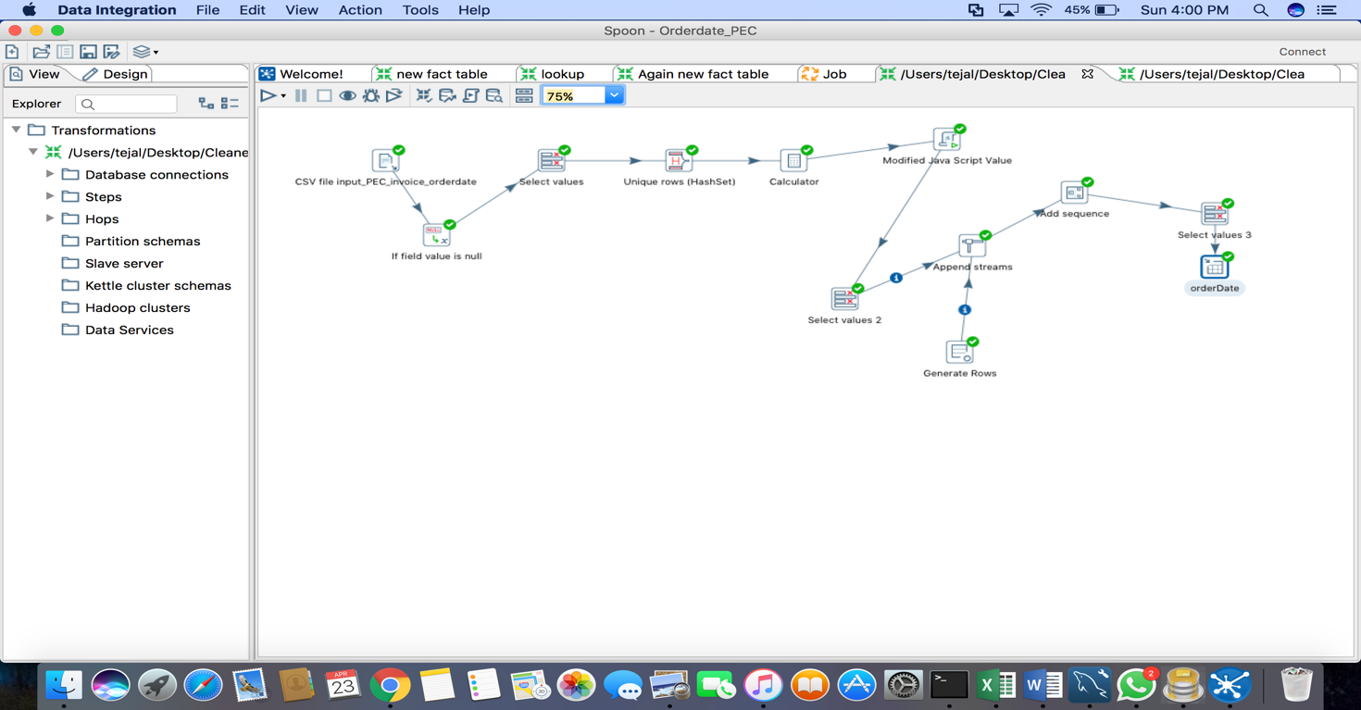

1. **Sales Date Dimension:**

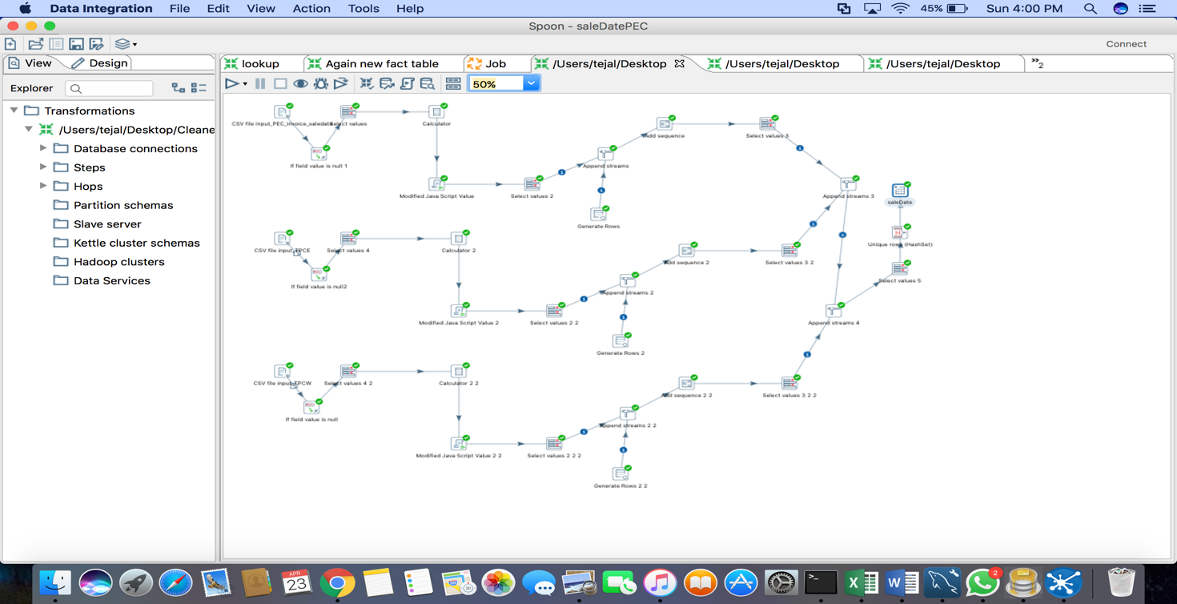

1. **Product Dimension:**

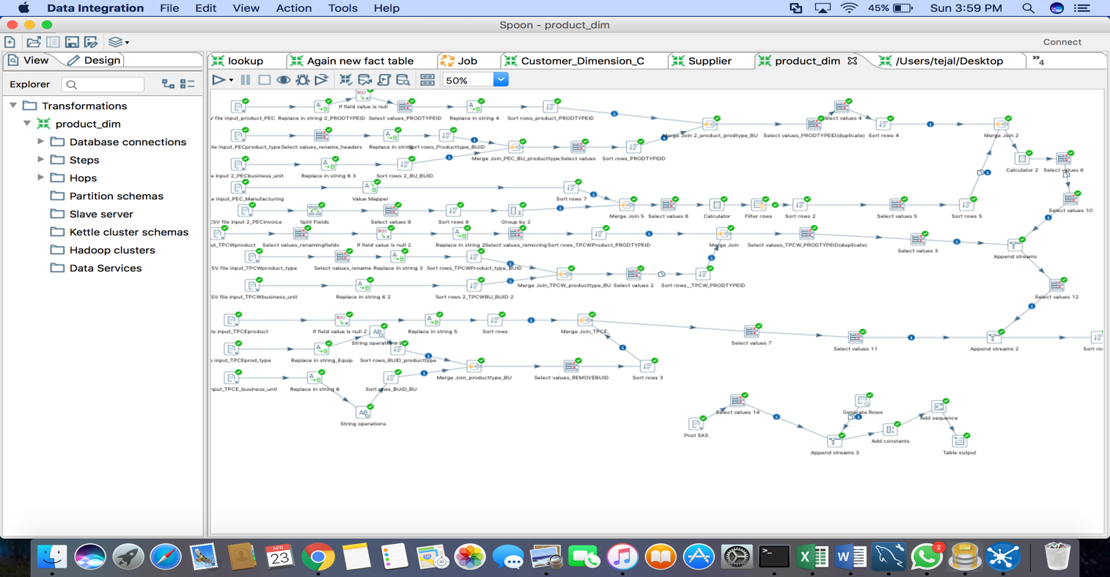

1. **Supplier Dimension:**

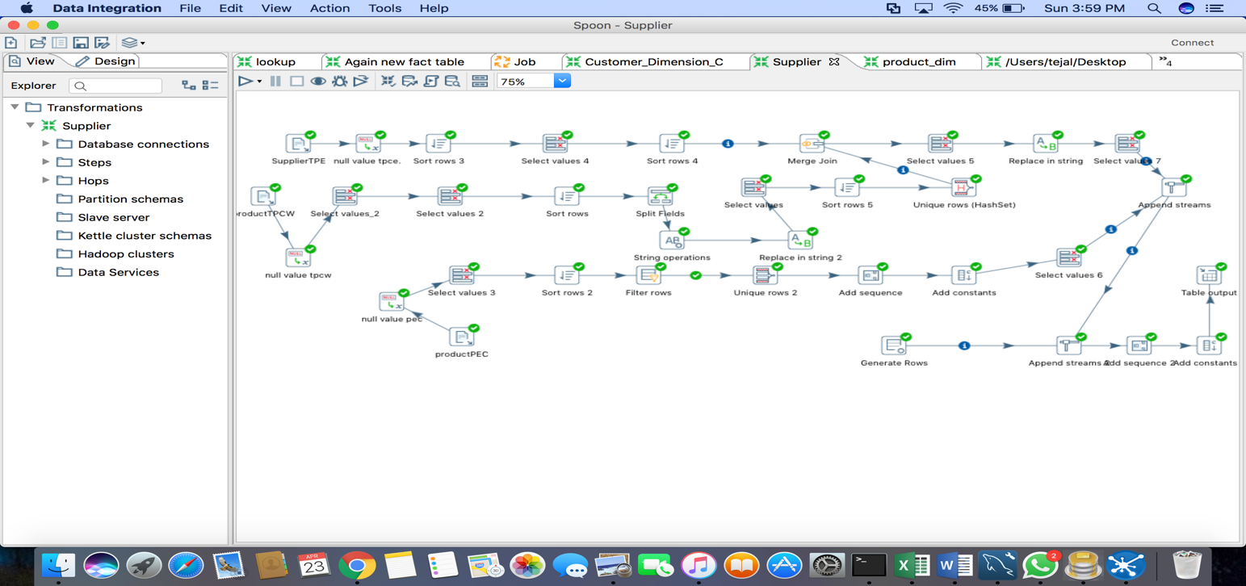

1. **Transaction Profile Dimension:**

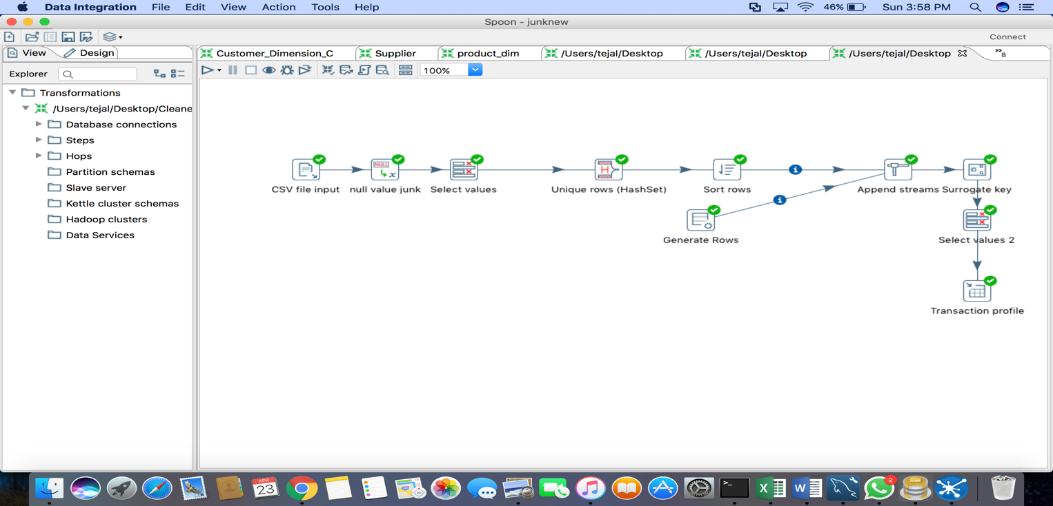

1. **Customer Dimension:**

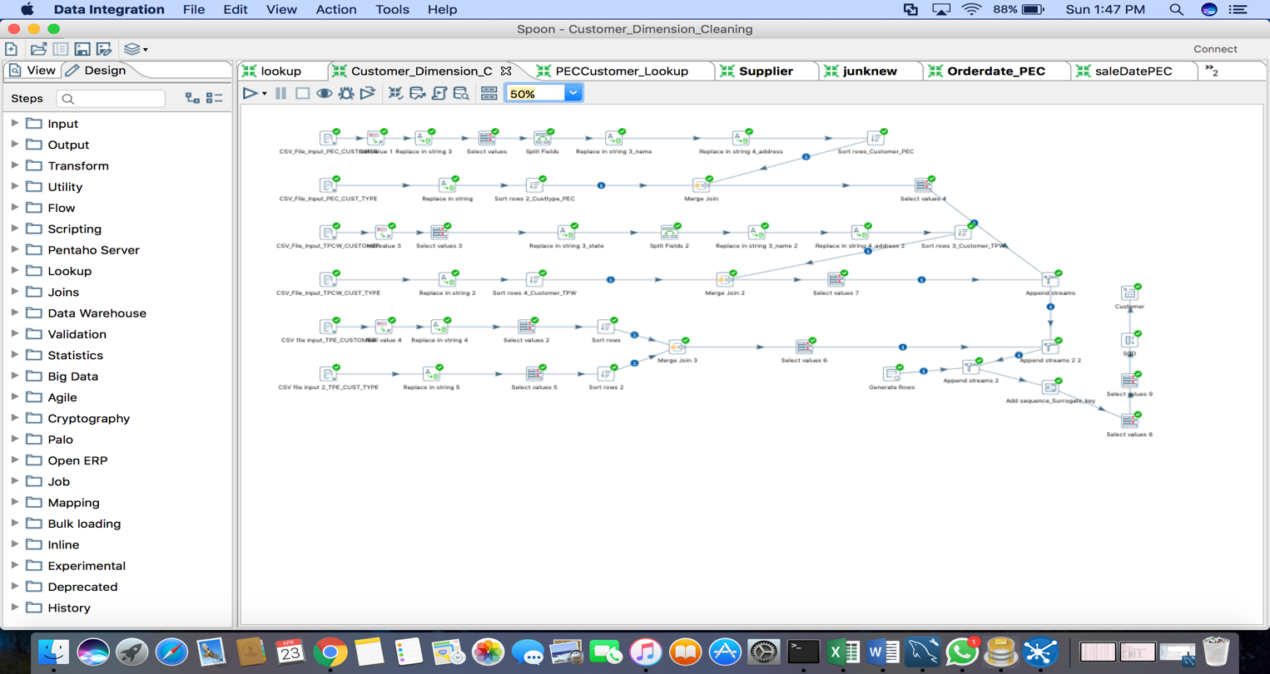

1. **Sales_Fact_Dimension**

**TPC-W**

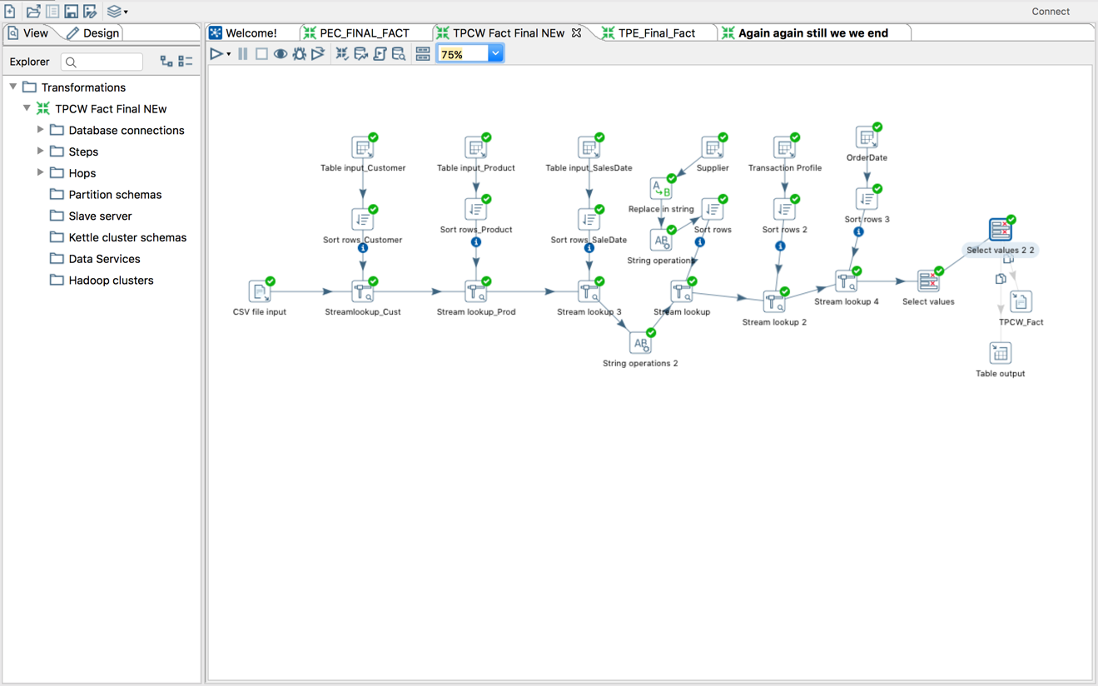

**PEC**

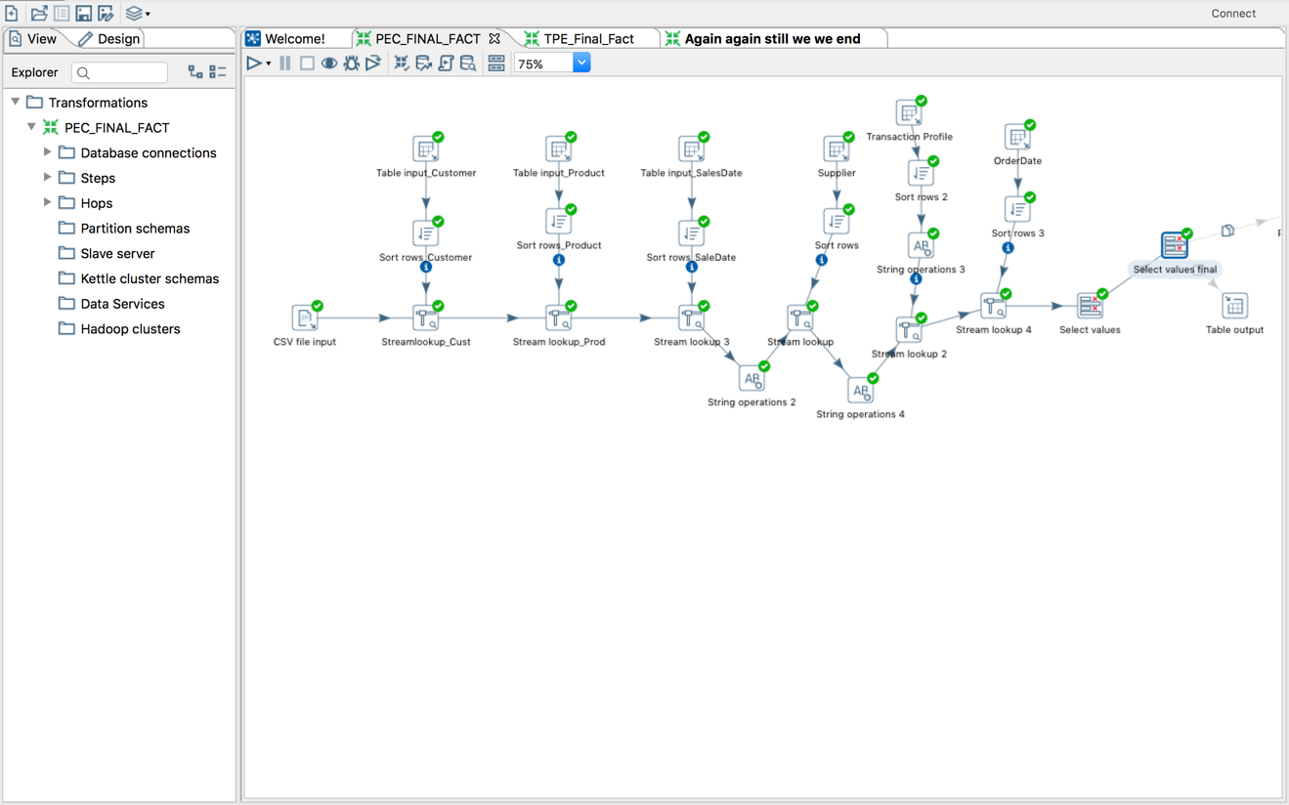

**TPC-E**

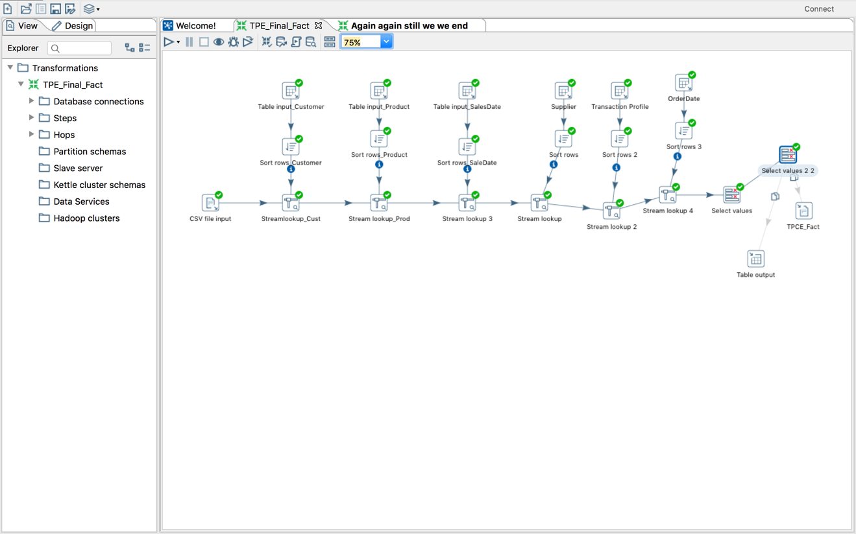

## **Table Population**

|  |  |  |
| --- | --- | --- |
| DM table | Table population process | Attach code |
| All dimension tables are populated using pentaho job. | All the ktr files were loaded through jobs in pentaho and we populated the tables using sql queries. |  |

**Tables populated using sql query in the terminal:**

1. **Customer_dimension:** select * from customer_dimension;

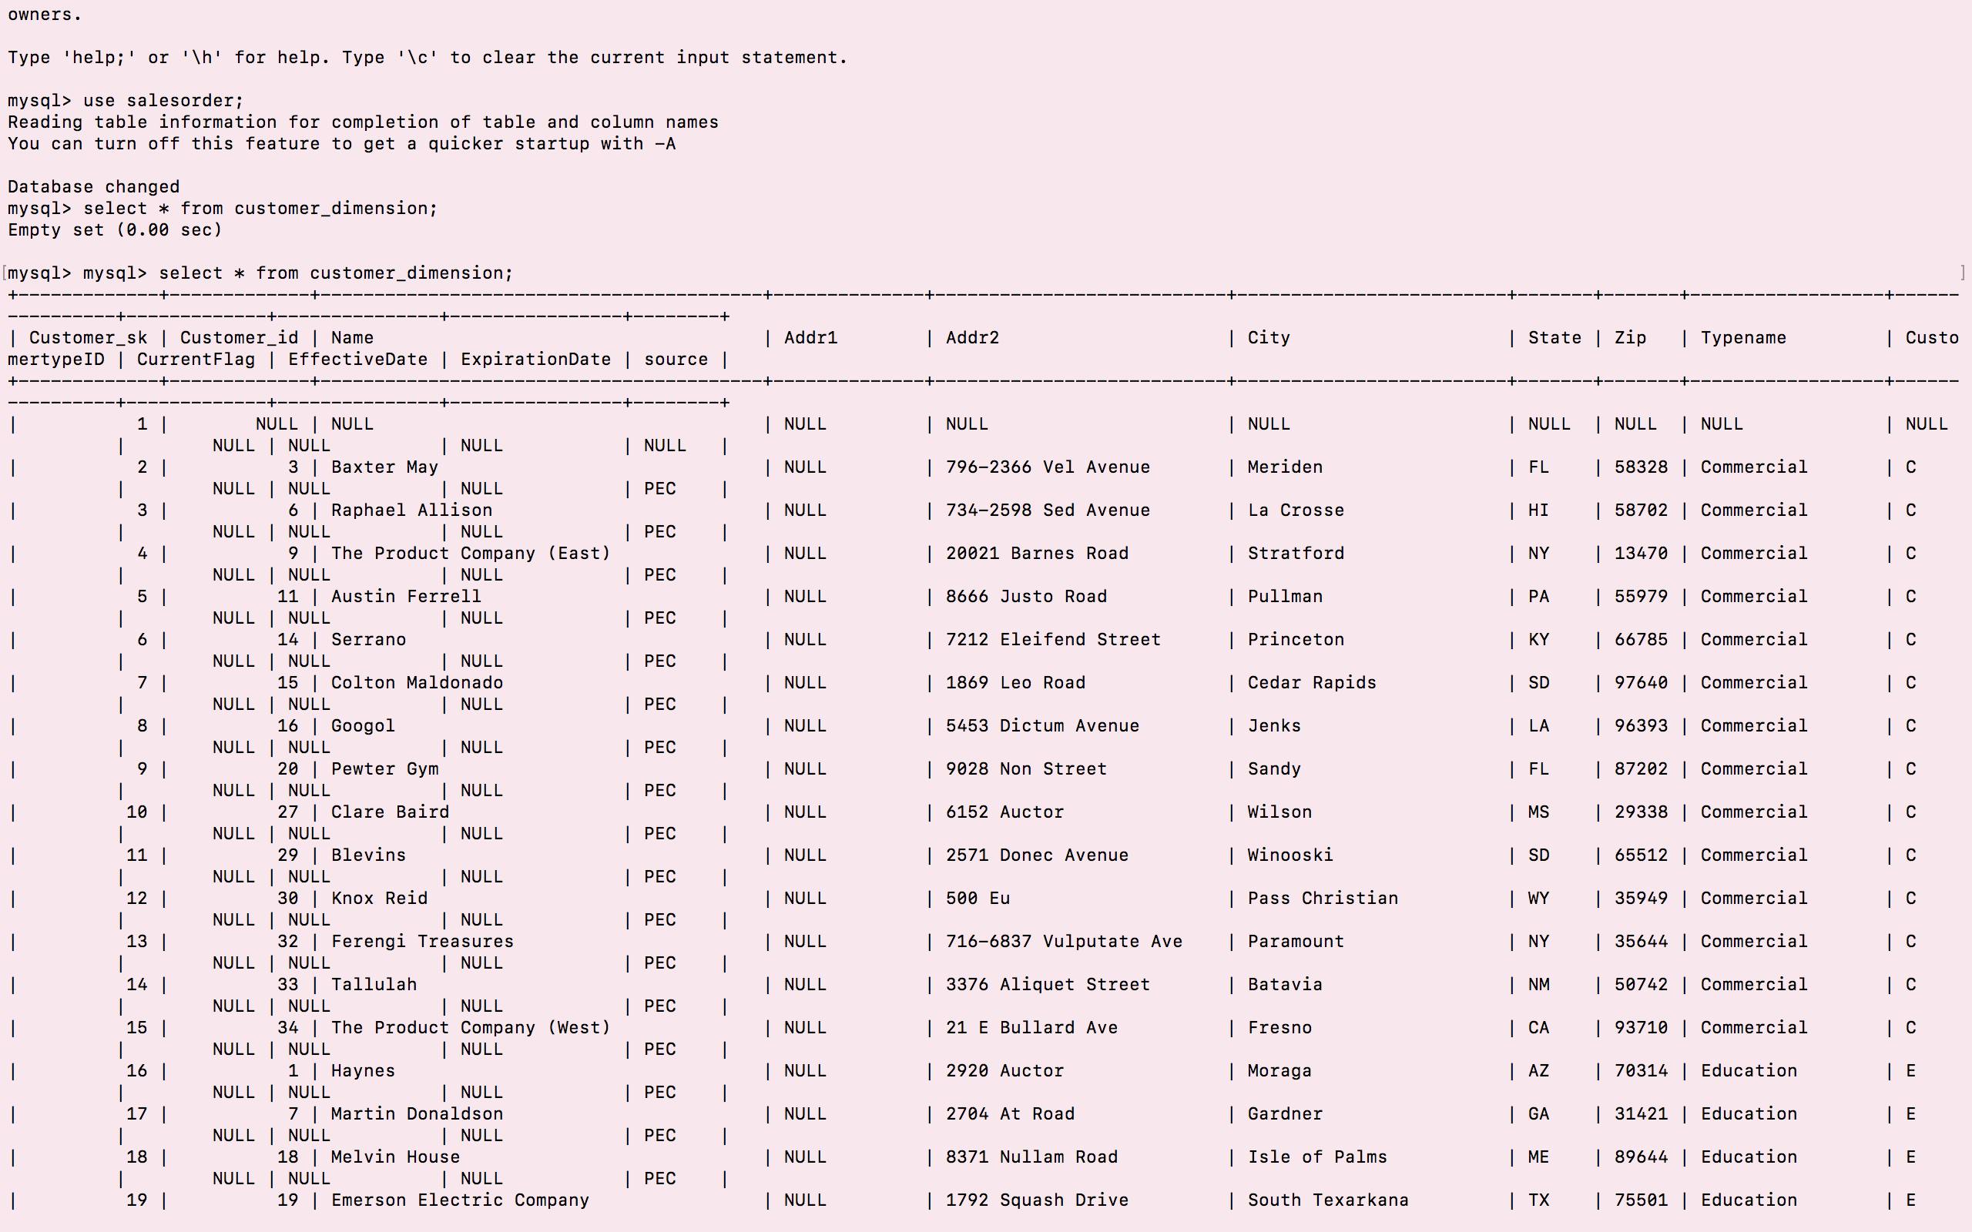

1. **Supplier_dimension** select * from supplier_dimension;

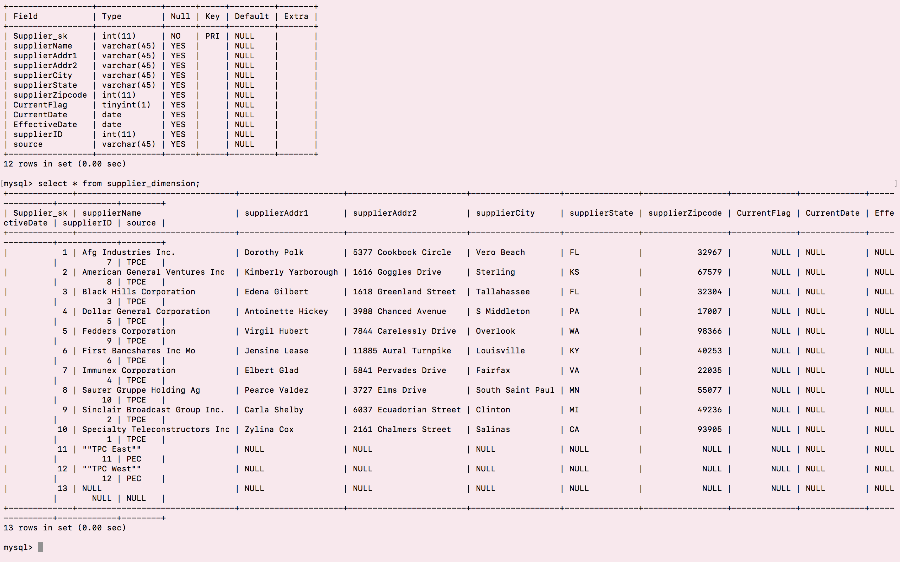

1. **Sale_date_dimension** select * from Sale_date_dimension;

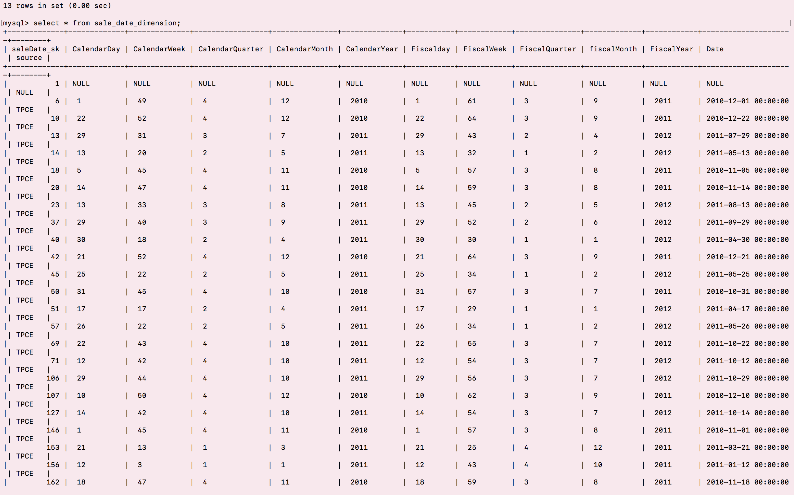

1. **Order_date_dimension** select * from Order_date_dimension;

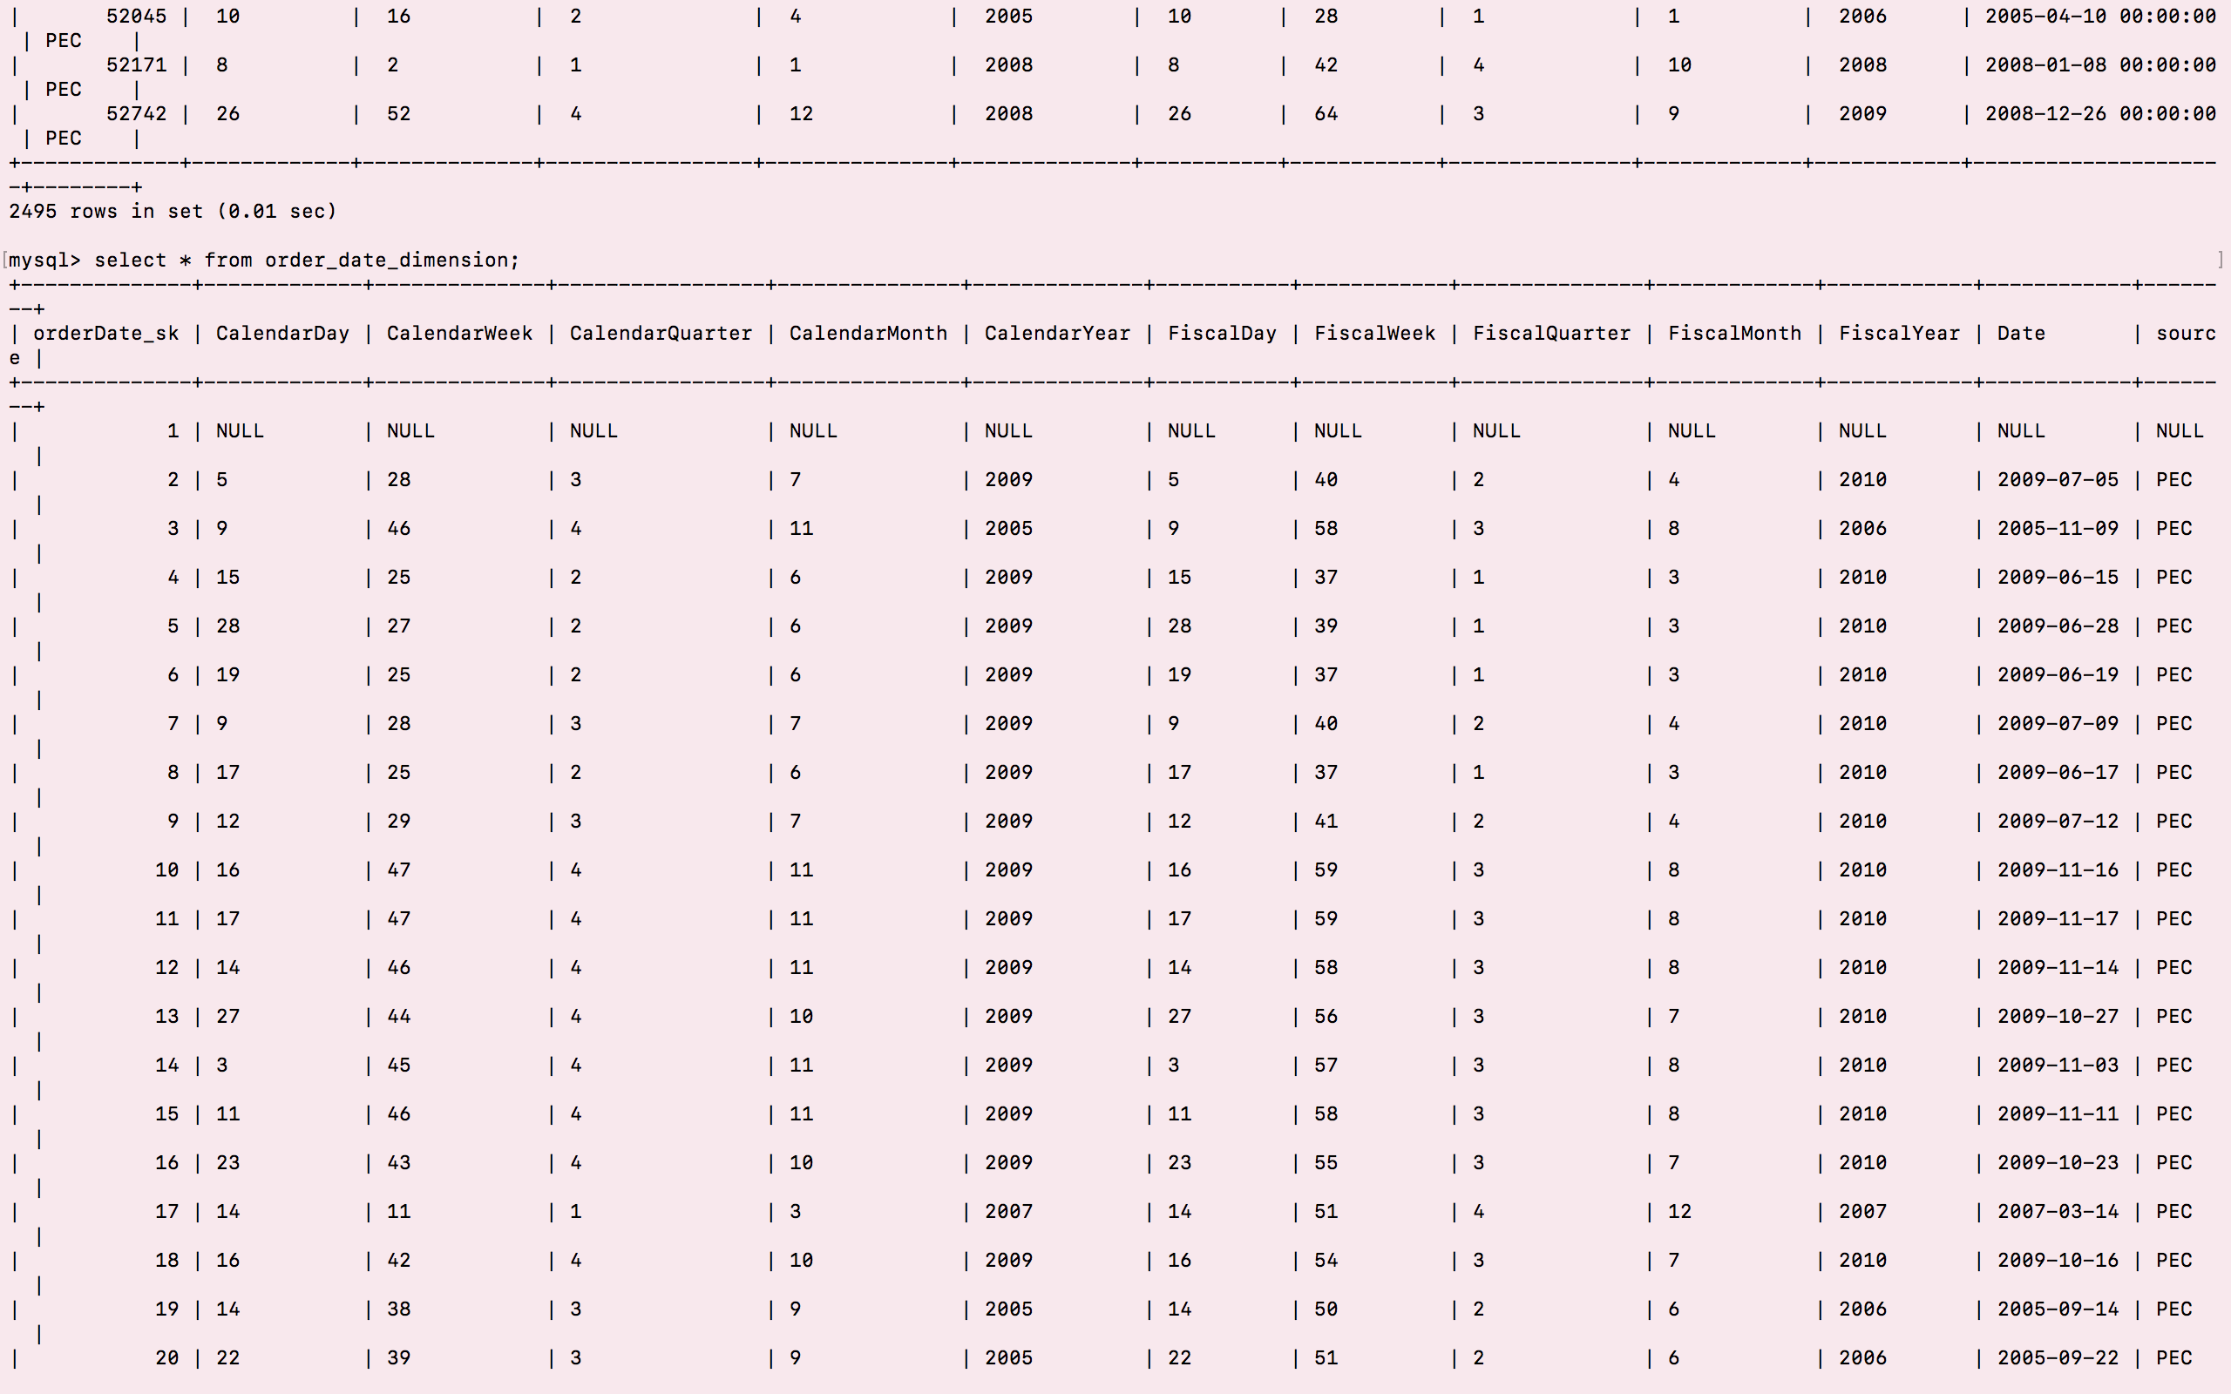

1. **Transaction_profile_dimension** select * from Transaction_profile_dimension;

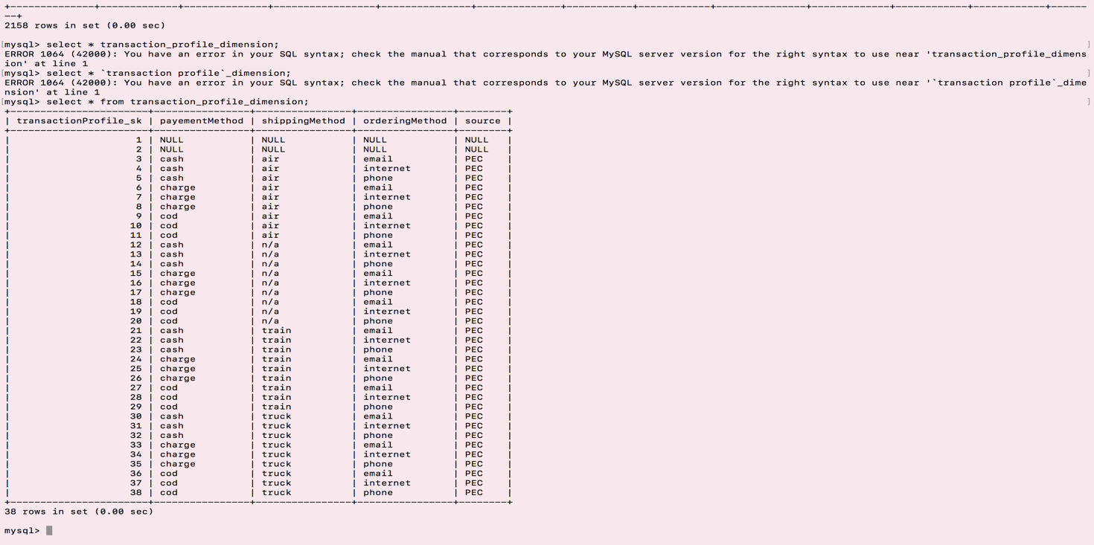

1. **Product_dimension** select * from product_dimension;

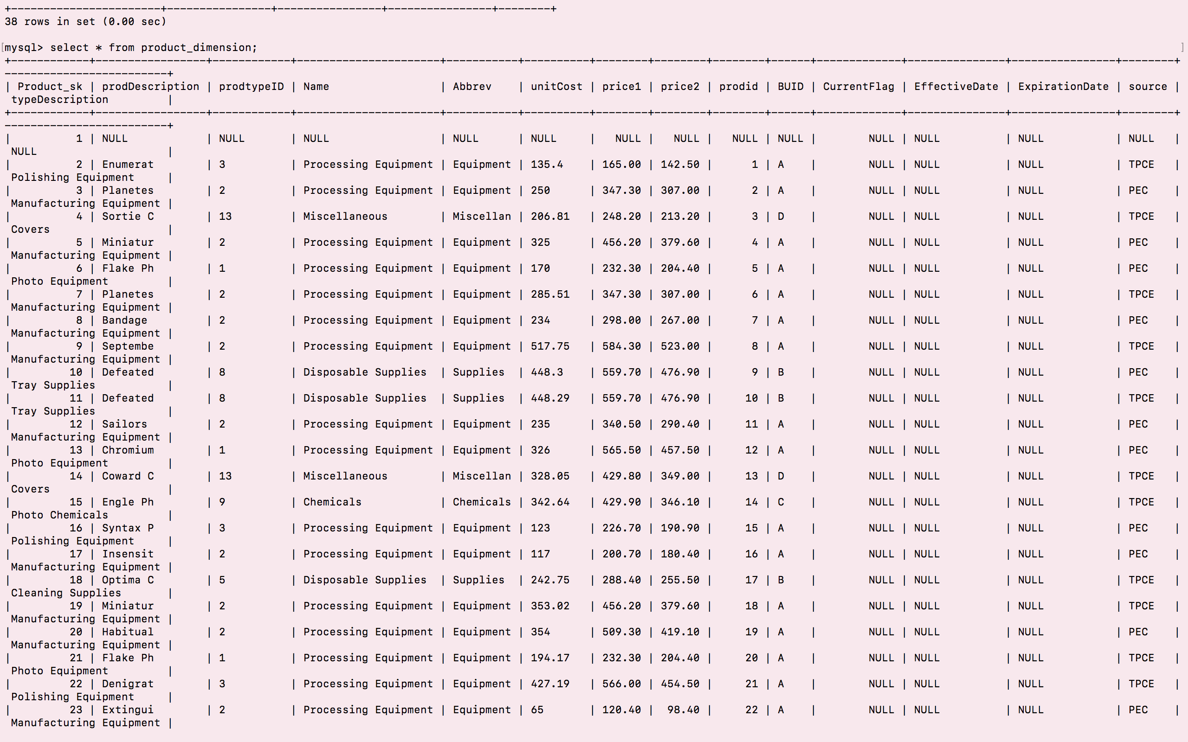

1. **Sales_Fact** select * from Sales_Fact_dimension;

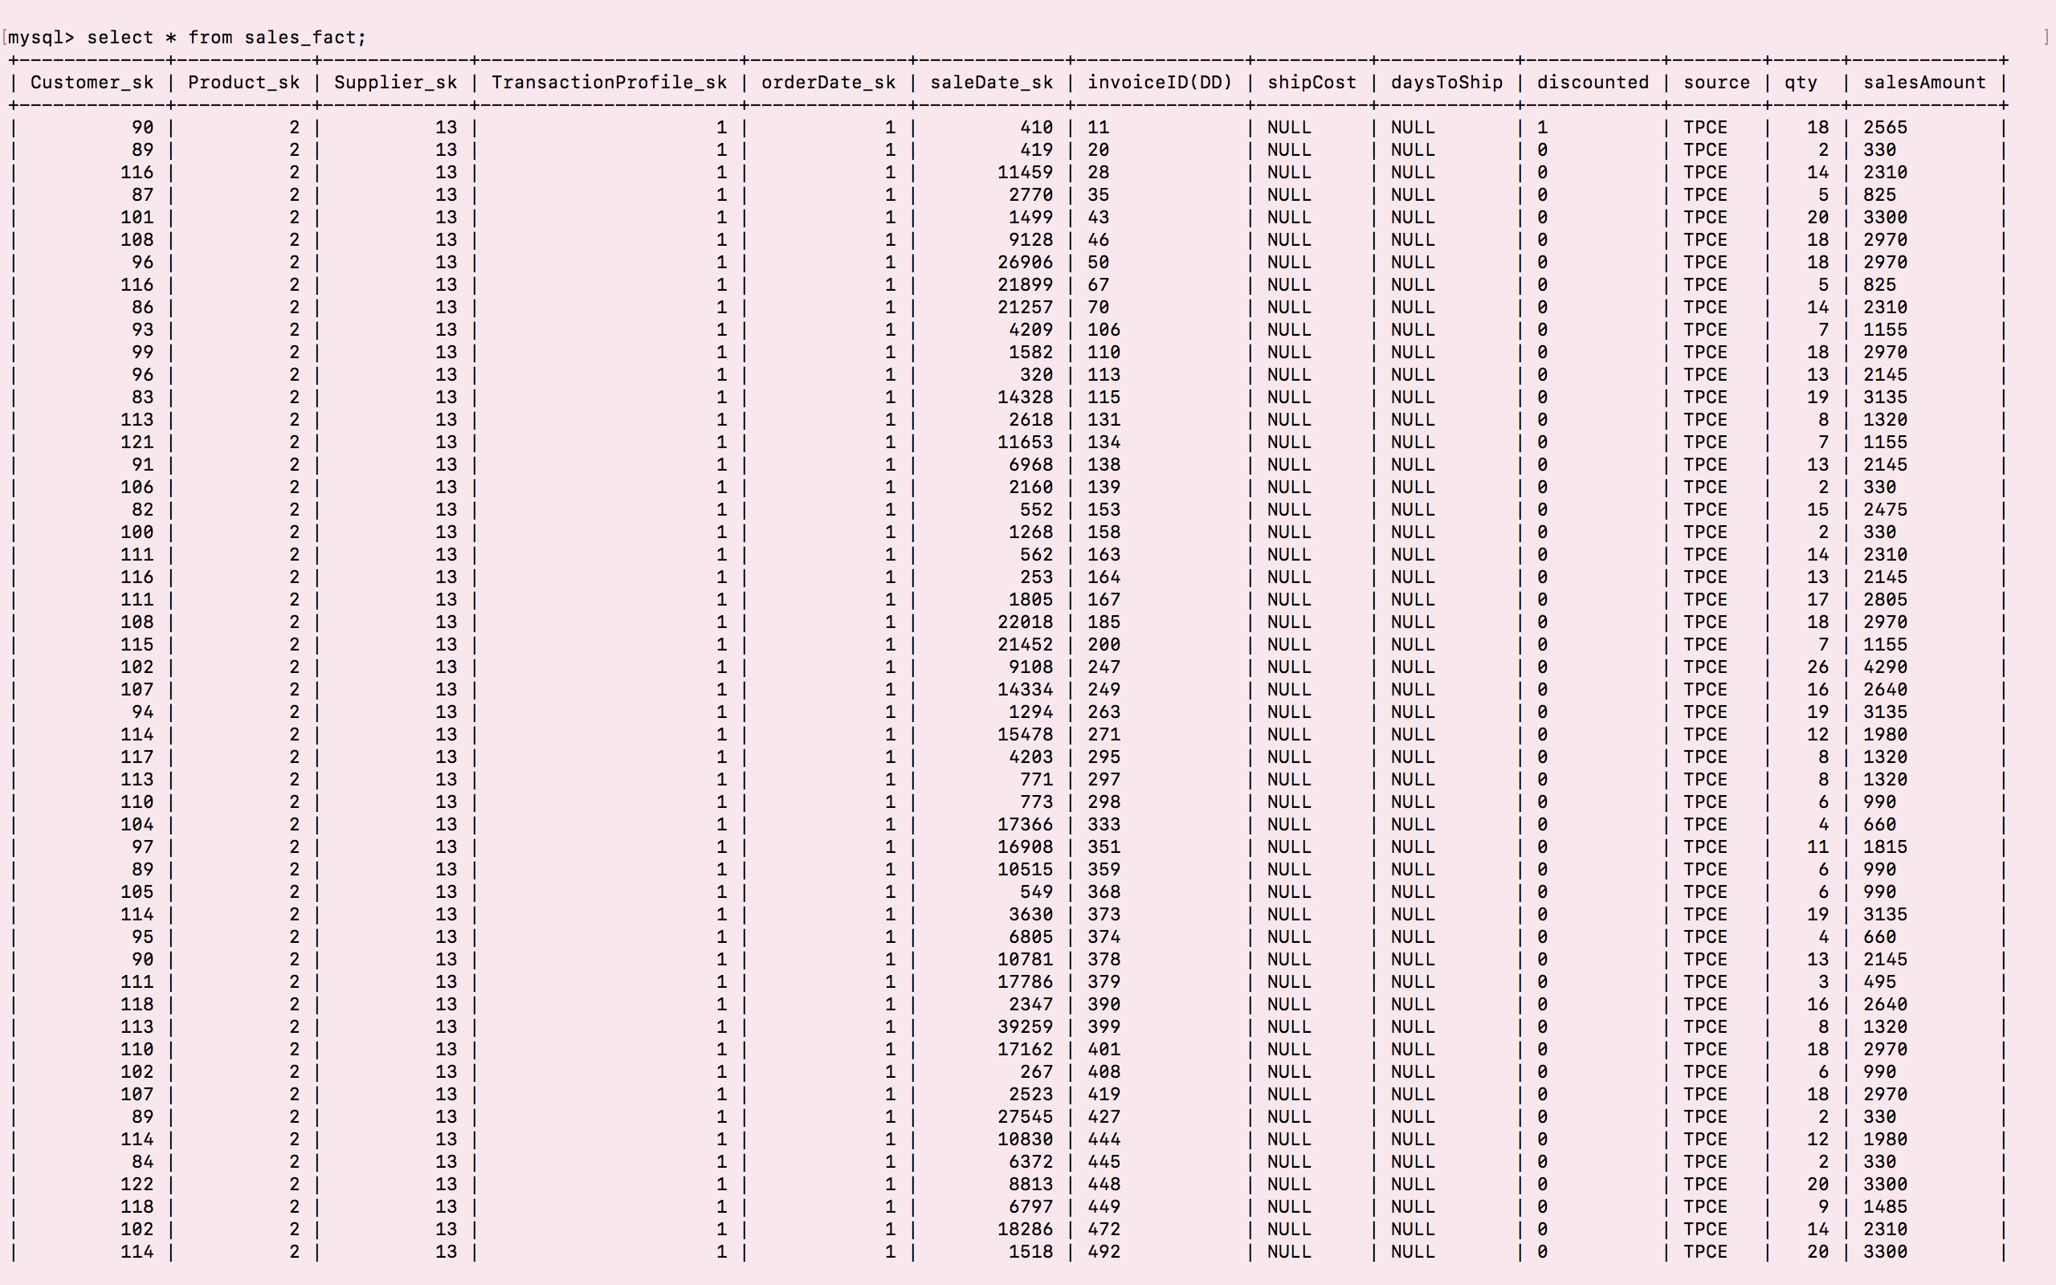

# VII. End User Applications

## **Queries using SQL99**

|  |
| --- |
| **User Question/Reporting Need** |
| 1. ***Slice to find sales by type of customer, by state, by product type and business unit*** |
| **SQL Code** |
| **select c.typeName as Customer_Type, typeDescription as Product_Type, BUID, c. state, SUM(f.salesAmount) TotalAmount**  **from sales_fact f join product_dimension p use index prodin using(product_sk)**  **join customer_dimension c using(customer_sk)**  **group by Customer_Type, Product_Type, BUID, state;** |
| **Supporting Index(es)**  **Create index prodin on product_dimension (prodDescription);** |
|  |

|  |
| --- |
| **User Question/Reporting Need** |
| 1. ***Drill Down on product to find description, type, total sales amount through year, quarter and month*** |
| **SQL Code** |
| **select prodDescription,sum(salesAmount) TotalAmount,typeDescription, CalendarMonth, CalendarQuarter,CalendarYear**  **from Sales_Fact sf join product_dimension pd use index prodin**  **using(product_sk)**  **join Sale_Date_Dimension d**  **on sf.saledate_sk = d.saledate_sk**  **group by prodDescription,typeDescription, CalendarYear;** |
| **Supporting Index(es)**  **Create index prodin on product_dimension (prodDescription);** |
|  |

|  |
| --- |
| **User Question/Reporting Need** |
| 1. ***Rank to find top customer*** |
| **SQL Code** |
| **select a.customer_sk, a.Name, a.CalendarYear, a.TotalSalesAmount, count(b.TotalSalesAmount) as Rank**  **from (select cd.Name, cd.customer_sk, d.CalendarYear, sum(salesAmount) TotalSalesAmount**  **from sales_fact f**  **inner join Customer_Dimension cd use index custin on f.customer_sk = cd.customer_sk**  **inner join Sale_Date_Dimension d on f.saleDate_sk = d.saleDate_sk**  **group by f.customer_sk) a**  **join**  **(select cd.Name, cd.customer_sk, d.CalendarYear, sum(salesAmount) TotalSalesAmount**  **from sales_fact f**  **inner join Customer_Dimension cd on f.customer_sk = cd.customer_sk**  **inner join Sale_Date_Dimension d on f.saleDate_sk = d.saleDate_sk**  **group by f.customer_sk) b**  **where a.TotalSalesAmount <= b.TotalSalesAmount**  **group by a.customer_sk, a.Name**  **order by a.TotalSalesAmount desc;** |
| **Supporting Index(es)**  **Create index custin on customer_dimension(Name);** |
|  |

## **2. A View**

1. A view (sales_view) so that end user can find total quantity of product purchased by the customer without querying the data mart.

create view sales_view as   
    select c.Name, c.typeName, p.typeDescription, p.unitCost,sum(f.qty) as TotalQuantity  
    from sales_fact f join Customer_Dimension c  
    using(customer_sk)  
    join product_dimension p  
    using(product_sk)  
    group by 1,2,3,4  
  
    select * from sales_view;  
  
    drop view sales_view;

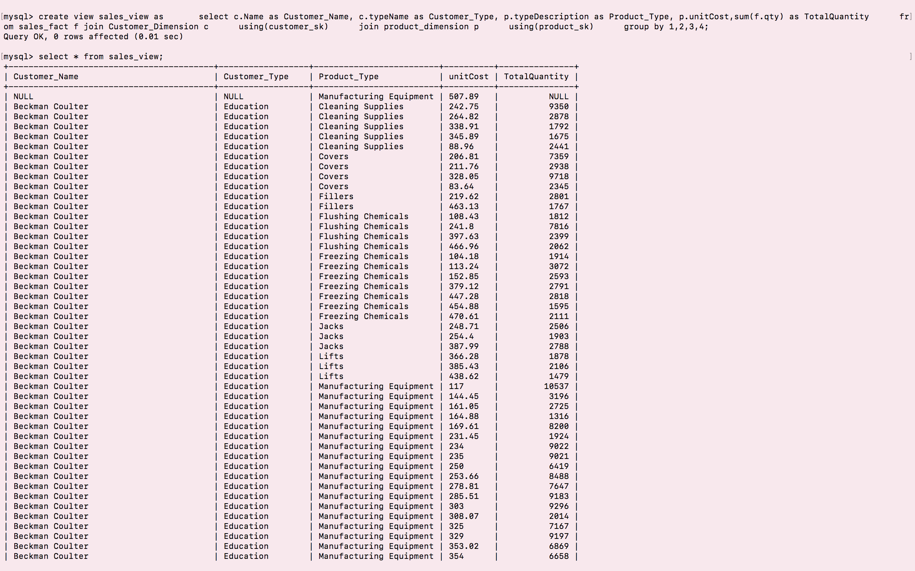

1. Created view so that end user can find total quantity of product supplied by the supplier without querying the data mart.

create view sales_view_supplier as   
    select s.supplierName, p.typeDescription, sum(f.qty) as TotalQuantity  
    from sales_fact f join Supplier_Dimension s  
    using(supplier_sk)  
    join product_dimension p  
    using(product_sk)  
    group by 1,2;  
  
    select * from sales_view_supplier;

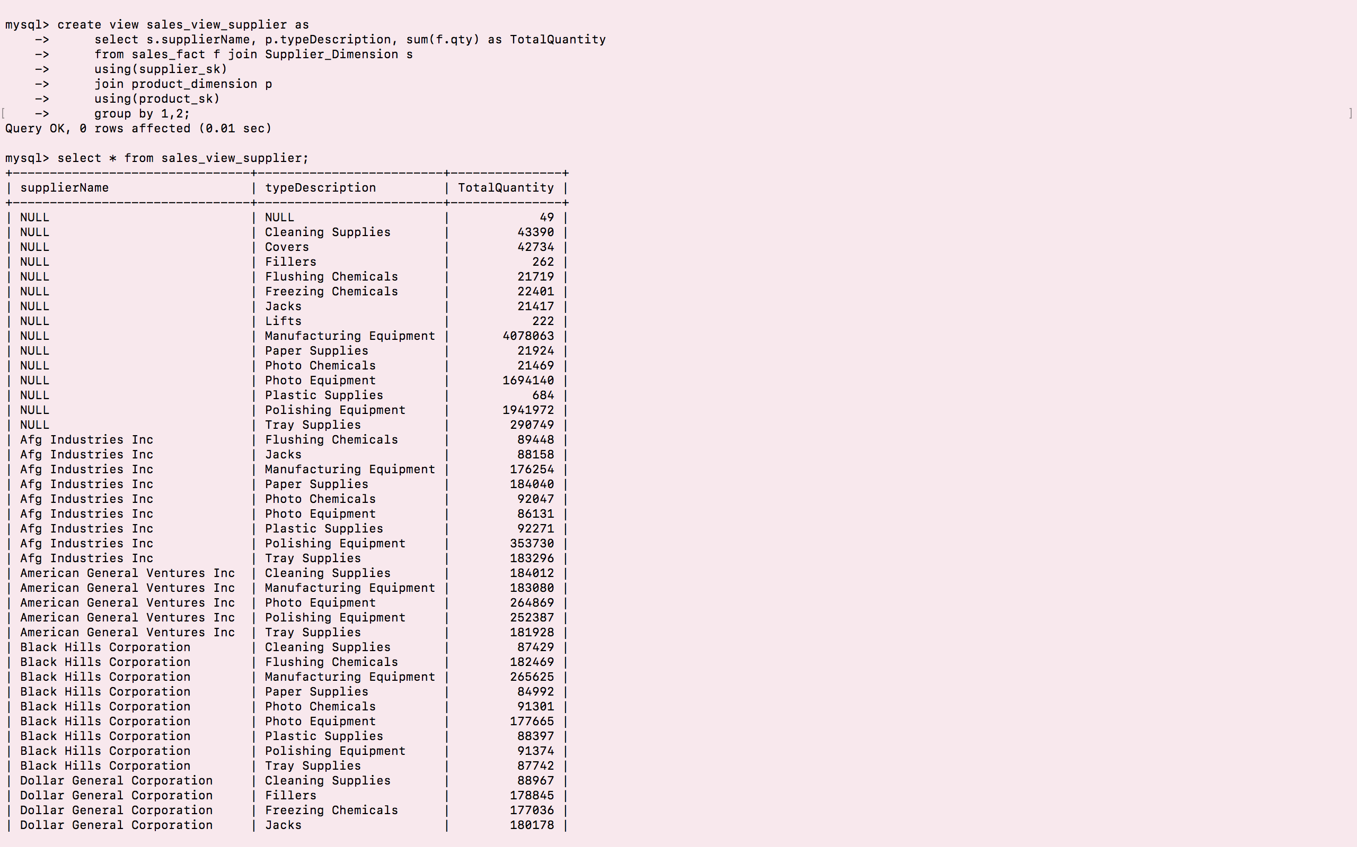

1. **Aggregated Data Marts**

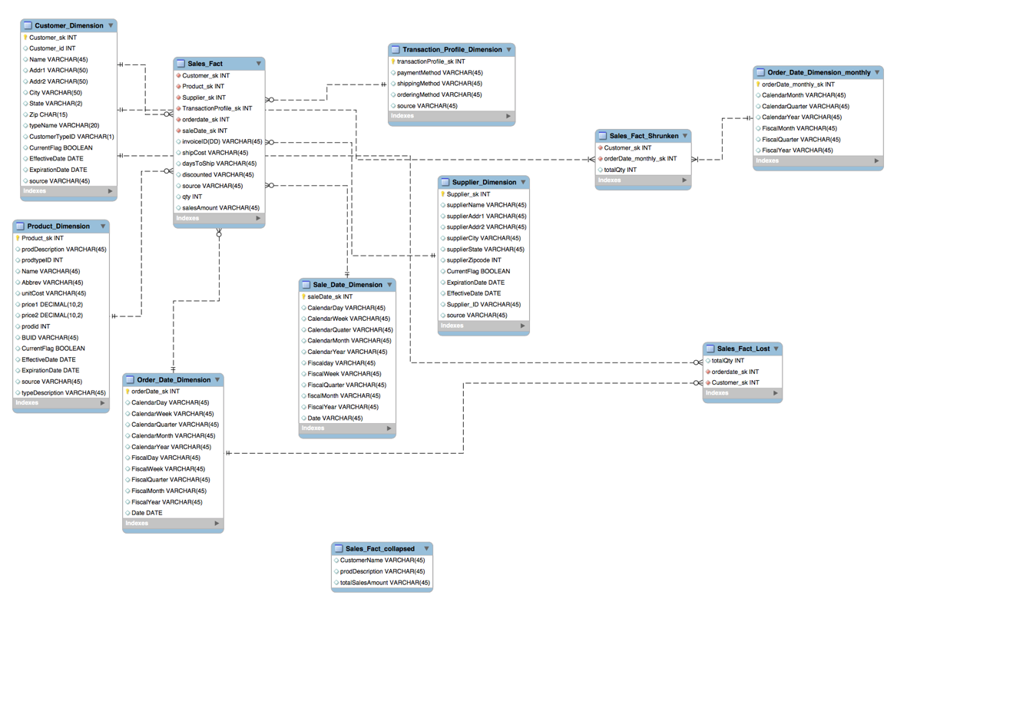

**Aggregated DataMart ERD**

**Three types of aggregated fact tables are implemented in the data mart**

1. Lost Fact
2. Shrunken Fact
3. Collapsed Fact

**\*\*Aggregated dump file submitted electronically**

Use Case List

|  |  |
| --- | --- |
| Primary Actor | Use Cases |
| TPC Management | Lost Fact Table |
|  | Shrunken Fact Table |
|  | Collapsed Fact Table |
|  |  |

Use Case Template

|  |  |  |  |
| --- | --- | --- | --- |
| Use Case ID: | 1 | | |
| Use Case Name: | Lost Fact Table | | |
| Created By: | Team 6 | Last Updated By: |  |
| Date Created: | 05/12/17 | Date Last Updated: |  |

|  |  |
| --- | --- |
| Actors: | TPC Management, Database |
| Description: | Total Quantity purchased by all customer on annual, monthly, quarterly, weekly or daily basis |
| Trigger: | End uses the database Sales Order. |
| Preconditions: | 1. Total quantity is calculated |
| Postconditions: | 1. End user can find total quantity for all customer |
| Normal Flow: | 1. Customer uses the database Sales Order 2. Customer query the whole Lost Fact Table. 3. Customer get the results. |
| Alternative Flows: | b.1) End User query the lost fact table for customer.  b.2) End User query the lost fact table for all customer for a year/quarter/month/week/daily. |
| Exceptions: | 1. Database is not present. 2. Lost Fact table does not have any records. 3. Year/month/quarter/week that customer querying is not present in the fact table. |
| *Includes: |  |
| Priority: |  |
| *Supplemental Information: |  |

Use Case Template

|  |  |  |  |
| --- | --- | --- | --- |
| Use Case ID: | 2 | | |
| Use Case Name: | Shrunken Fact Table | | |
| Created By: | Team 6 | Last Updated By: |  |
| Date Created: | 05/12/17 | Date Last Updated: |  |

|  |  |
| --- | --- |
| Actors: | TPC Management, Database |
| Description: | Total Quantity purchased by all customer on annual, monthly, quarterly basis only. |
| Trigger: | End user uses the database Sales Order. |
| Preconditions: | 1. Total quantity is calculated 2. Date dimension grain is month. |
| Post conditions: | 1. End user can find total quantity for all customer on monthly/quarterly/annually basis. |
| Normal Flow: | 1. Customer uses the database Sales Order 2. Customer query the whole Shrunken Fact Table. 3. Customer get the results. |
| Alternative Flows: | b.1) End User query the shrunken fact table for customer.  b.2) End User query the shrunken fact table for all customer on annually/quarterly/monthly basis. |
| Exceptions: | 1. Database is not present. 2. Shrunken Fact table does not have any records.   iii) End User is querying on daily or weekly basis. |
| *Includes: |  |
| Priority: |  |
| *Supplemental Information: |  |

Use Case Template

|  |  |  |  |
| --- | --- | --- | --- |
| Use Case ID: | 3 | | |
| Use Case Name: | Collapsed Fact Table | | |
| Created By: | Team 6 | Last Updated By: |  |
| Date Created: | 05/12/17 | Date Last Updated: |  |

|  |  |
| --- | --- |
| Actors: | TPC Management, Database |
| Description: | Total sales amount for customer and the product purchased by them can be found. |
| Trigger: | End user uses the database Sales Order. |
| Preconditions: | 1. Total sales Amount is calculated 2. Customer and Product data is present in the fact table. |
| Post conditions: | 1. End user can find total sales amount for all customer and product |
| Normal Flow: | 1. Customer uses the database Sales Order 2. Customer query the whole Collapsed Fact Table. 3. Customer get the results. |
| Alternative Flows: | b.1) End User query the collapsed fact table for customer.  b.2) End User query the collapsed fact table for a product. |
| Exceptions: | 1. Database is not present. 2. Collapsed Fact table does not have any records. 3. Customer or Product records which end user is querying are not present |
| *Includes: |  |
| Priority: |  |
| *Supplemental Information: |  |

|  |
| --- |
| **Lost Fact Table** |
| 1. User can find total Quantity purchased by all customer on annual, monthly, quarterly, weekly or daily basis |
| **SQL Code for Loading** |
|  |
| **SQL Code for Summary Query** |
|  |
|  |

|  |
| --- |
| **Shrunken Fact Table** |
| 1. User can find Total Quantity purchased by all customer on annual, monthly, quarterly basis only. |
| **SQL Code for Loading order_date_dimension_monthly**  **&**  **Loading Shrunken Fact Table** |
|  |
| **SQL Code for Summary Query** |
|  |
|  |

|  |
| --- |
| **Collapsed Fact Table** |
| 1. User can find Total sales amount for product purchased by the customer |
| **SQL Code for Loading Collapsed Fact Table** |
|  |
| **SQL Code for Summary Query** |
|  |
|  |

# VIII. Handling Slowly Changing Dimensions (SCD)

What type of slowly changing dimension would you implement? Why? (There should be at least two different SCD types other than Type 0)

In our data mart, we have implemented type 1 and type 2 slowly changing dimensions for customer_dimension table.

**Type1:** This type of SCD is used when data error occurs. The wrong dimension value is overwritten by the new one. For instance, change Name of the customer.

**Type2:**In this type of SCD we insert a new record. The history of the dimension changes is maintained in the database for future purpose as data warehouse stores historic data by using attributes such as Expiration date, Effective date and version. The attribute change is captured by adding a new row with a new surrogate key to the dimension table. Both the prior and new rows contain attributes and natural key.

**Implementation**

We used insert/update in Pentaho to implement Type1 SCD.

***Type 1:***

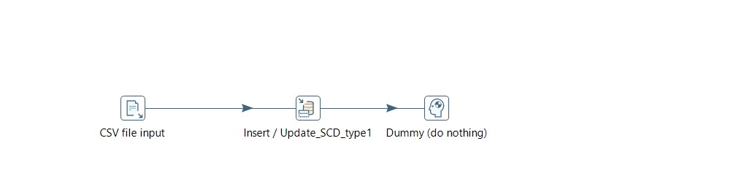

We used Dimensional lookup/update in Pentaho to implement Type 2 SCD.

***Type 2:*** 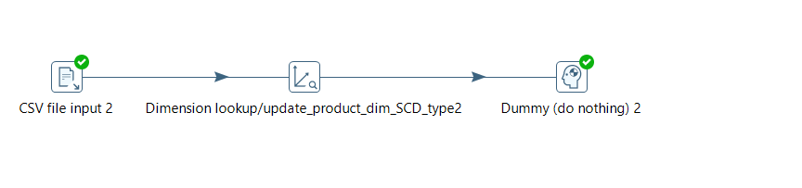

***Code: Type 1***

1. Customer_id =3 was Baxter May



After implementing SCD type 1 the Customer_id =3 was updated to Baxter Mayer.

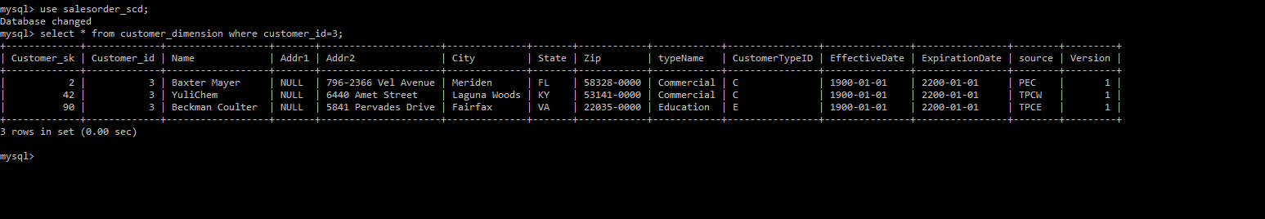

1. For Customer_id=7 the name was Martin Donaldson



After implementing SCD type 1 the Customer_id=7 was updated to Martini Donaldson.

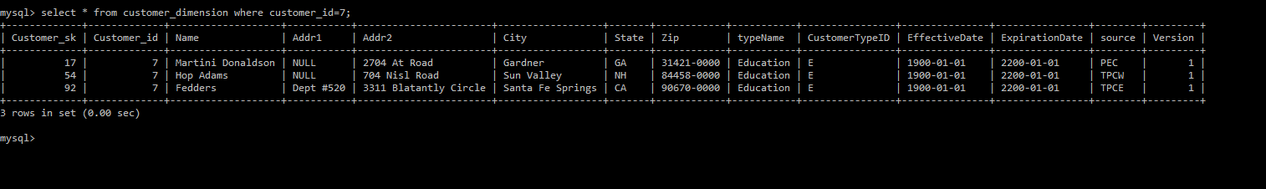

***Code: Type 2***

1. From the below example, we can see the changes in the Addr2 was inserted as Justor from Justo and the history was retained.



1. From the below example, we can see the changes in the City was inserted as Princenton from Princeton and the history was retained.

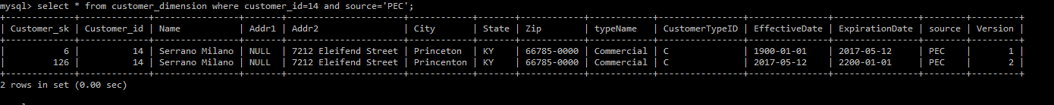

1. From the below example, we can see the changes in the City was inserted as New York from Famington and the history was retained.



***SCD Type 6:*** Is the combination of SCD type 2+3+1. In this method history of all the tables along with its version can be stored in the data mart. SCD can be implemented by adding new columns to the dimension table using alter statement.

1. Add new columns ‘Coulmn_Name1’, ‘Coulmn_Name2’, ‘Coulmn_Name3’

alter table tablename add column Coulmn_Name1VARCHAR(45) NOT NULL default 'value1';

alter table tablename add column Coulmn_Name2VARCHAR(45) NOT NULL default 'value2';

alter table tablename add column Coulmn_Name3 VARCHAR(45) NOT NULL default 'value3';

# IX. Many-to-Many (N-M) Relationship Implementation Option

1. What implementation strategy do you propose? What are other options? Justify your choice of implementation.

In our project, we have proposed Bridge Table Method Strategy where we have created many to many relationship between supplier and shipping company using bridge table. Other options available are:

1. ***Boolean column method strategy:*** In this method, the user adds a new column in the dimension table for each possible value that are present, where each column will be either single integer as (0 or 1) or a single character as (Y or N) [2]. This method is used mostly when we have a predefined possible value.
2. ***Multiple column method strategy:*** In this method, there are number of columns according to the user requirement. This approach can be used when we have a set of different choices or categories that related to defined record.

**Justification**

In this method, we created a new shipping dimension that consisted various attributed like name, state, zip etc. of the company and was connected to supplier dimension table using bridge table named as supplier_shipping_dimension. The bridge table was referenced using surrogate keys from both dimension table. This method will handle many to many relationship this is because one supplier can have many shipping company and one shipping company can have many supplier. Therefore, in this method user can easily update the information on both tables.

***References:***

1. Rowen, W., Song, I. Y., Medsker, C., & Ewen, E. (2001). An analysis of many-to-many relationships between fact and dimension tables in dimensional modeling. In Proceedings of the International Workshop on Design and Management of Data Warehouses (DMDW 2001), Interlaken, Switzerland.
2. Hammel, R. (2007, January 19). Implementing Many-to-many Relationships in Data Warehousing. Retrieved May 16, 2016, from https://www.pythian.com/blog/implementing-many-to-many-relationships-in-data-warehousing/

***Screenshot of Many-to-Many (N-M) Relation***

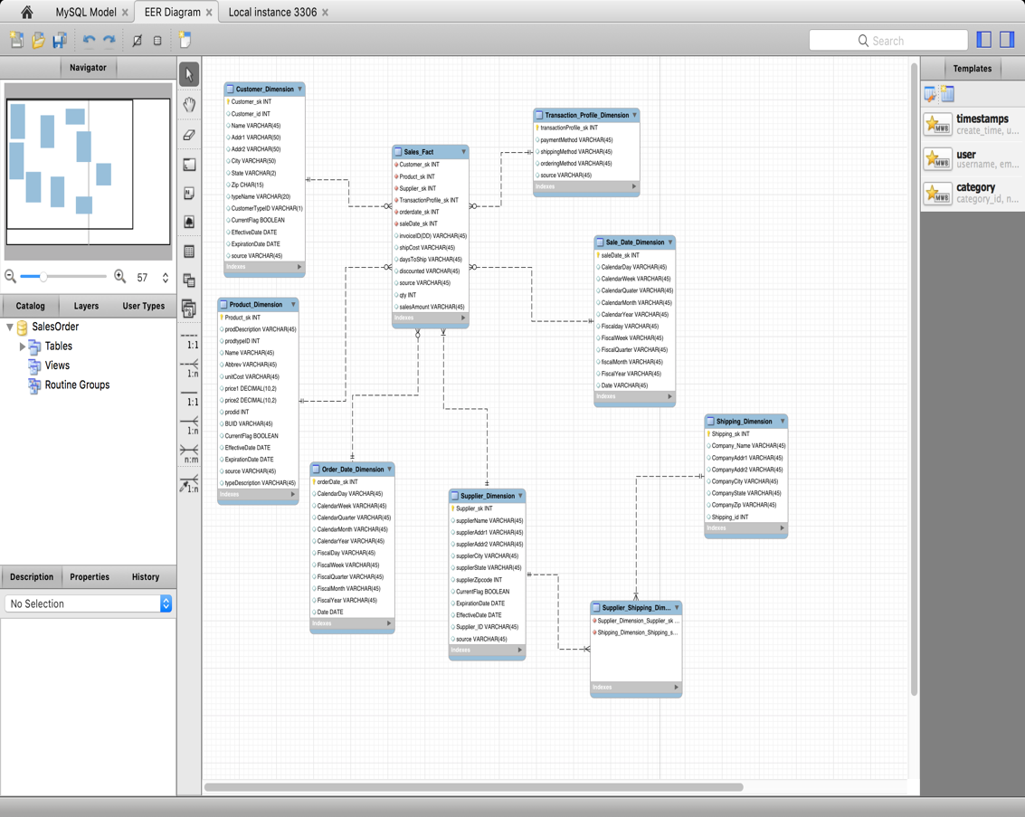

# X. Appendix (Fix Lab #3 Problems)

**LAB 03 Mistakes Rectified:**

1. Deliverables: We had provided one csv cleaned file for product for all the sources, similarly for customers, therefore at this stage the three sources were separated and then cleaned individual csv files are provided for product and customer.

**Product.ktr**

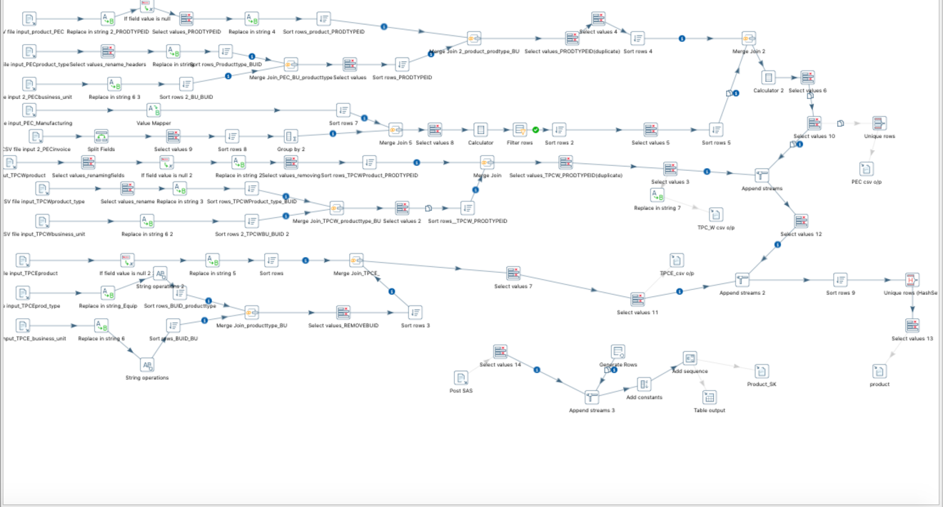

**Customer.ktr**

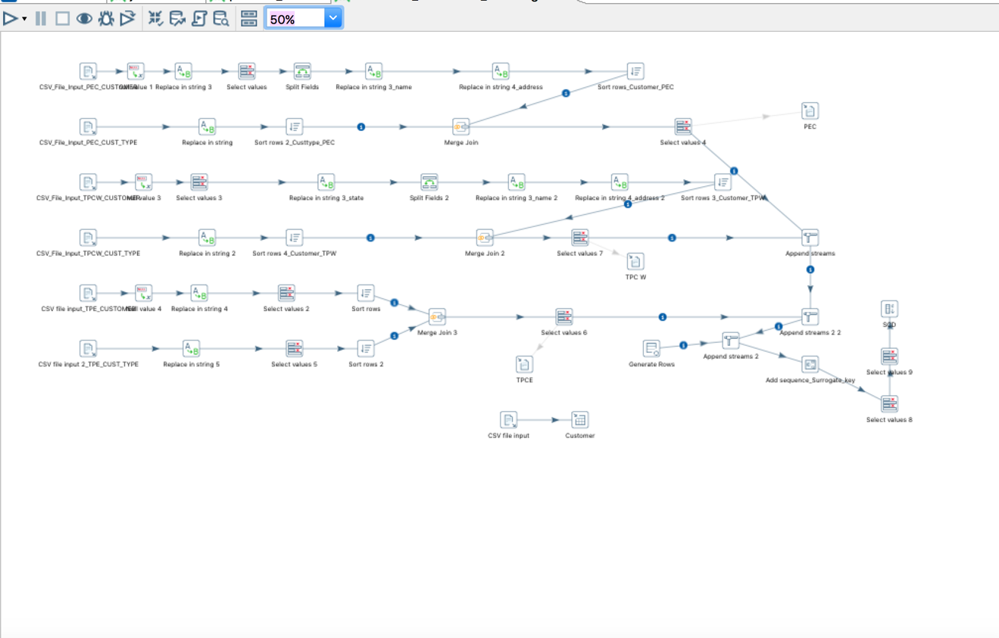

1. The sales amount for PEC invoice was not calculated, however in the project phase used the calculator in the ktr file and the right sales amount was computed and loaded into the salesfact table.

The clean sales fact.csv file has been submitted electronically.

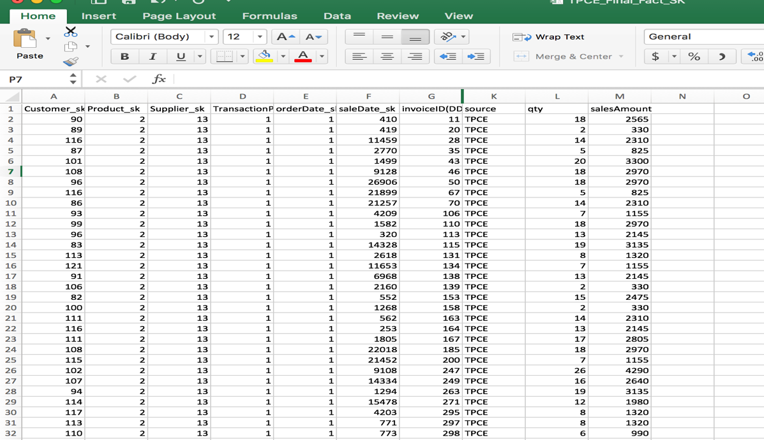

1. There were duplicate entries in the TPC_W product csv file, used filter and removed the duplicate irrelevant values using pentaho.

The clean product.csv file has been submitted electronically.

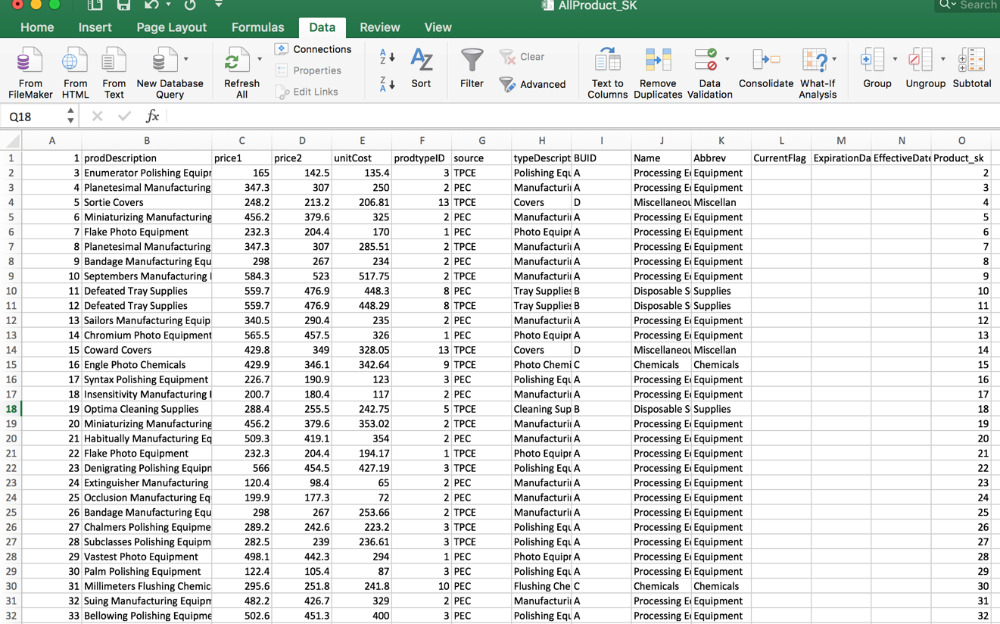

1. In the TPC_W customer csv zip code was not in the standard format, therefore zero were appended to the zip code manually through excel and it was standardized.

The clean customer.csv file has been submitted electronically as well.

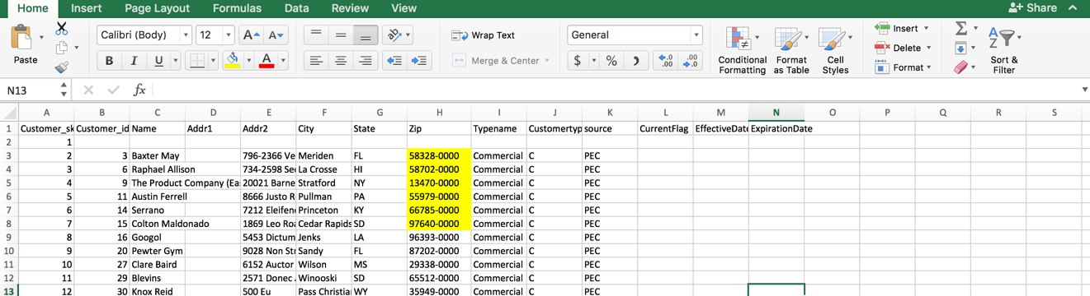

1. In TPC_W invoice there were null records for discounted values and quantity the ktr transformation was performed and the right values were computed and replaced with the null value.

The clean sales_fact.csv file has been submitted electronically as well.

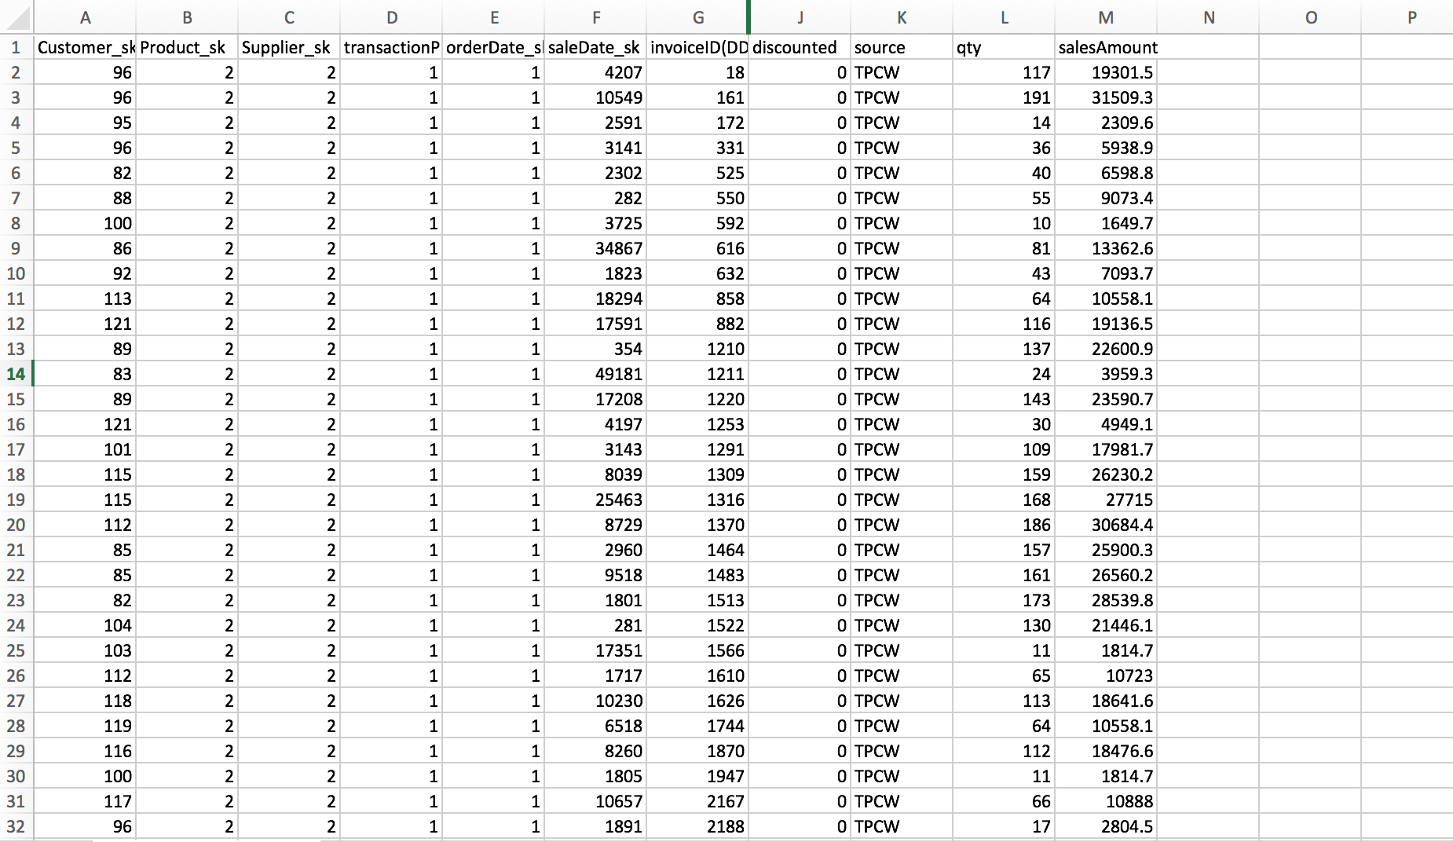

1. There were inconsistencies in the Ave. was replaced as Avenue using replace

string in pentaho and the Inc. was changed to Inc using replacing string in pentaho.

The clean customer.csv file has been submitted electronically as well.

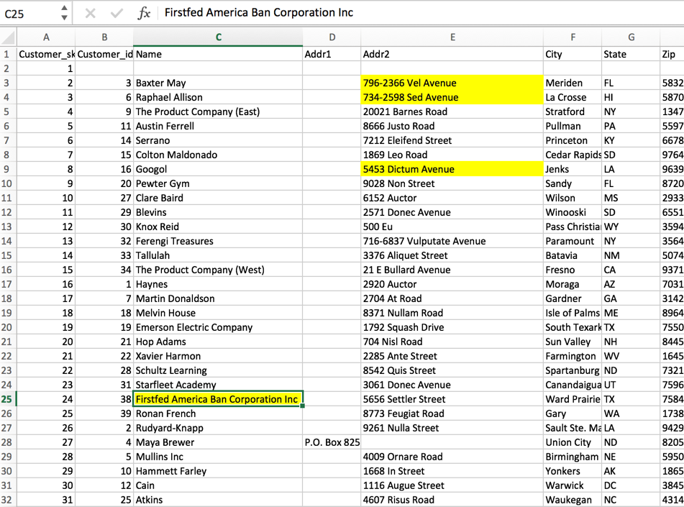

1. The queries that were not submitted in Lab 03 are submitted with screen shots of the results.

|  |
| --- |
| **User Question/Reporting Need** |
| 1. ***Summary query to show the sales, and costs associated with each customer or customer type on an annual, quarterly, monthly or weekly basis*** |
| **SQL Code** |
| Select cd.Name,cd.typeName, f.salesAmount,f.qty, d.CalendarYear, d.CalendarQuarter, d.CalendarMonth  from Sales_Fact f inner join customer_dimension cd use index(custin)  using (Customer_sk)  join order_date_dimension d on f.orderdate_sk = d.orderdate_sk  group by CalendarYear ; |
| **Supporting Index(es)**  **Create index custin on customer_dimension(Name);** |
|  |

|  |
| --- |
| **User Question/Reporting Need** |
| 1. ***Summary query to show the sales, and costs associate at the product level/ product type/ business unit*** |
| **SQL Code** |
| select pd.prodDescription, pd.Name, pd.Abbrev,f.salesAmount,f.qty,pd.typeDescription,d.CalendarYear, d.CalendarQuarter, d.CalendarMonth  from Sales_Fact f  inner join product_dimension pd use index(prodin)  using (product_sk)  join order_date_dimension d  on f.orderdate_sk = d.orderdate_sk  group by CalendarYear ; |
| **Supporting Index(es)**  **Create index prodin on product_dimension (prodDescription);** |
|  |

|  |
| --- |
| **User Question/Reporting Need** |
| 1. ***Query to find the average number of products supplied by each supplier*** |
| **SQL Code** |
| select supplierName, prodDescription, qty  from sales_fact f  inner join supplier_dimension sd use index(suppin)  on f.supplier_sk = sd.supplier_sk  join product_dimension pd  on f.product_sk = pd.product_sk  group by supplierName; |
| **Supporting Index(es)**  **Create index suppin on supplier_dimension(supplierName);** |
|  |